Design Document for
Customer Service and SimplyOrder System
By JKKL Consulting

Document Description [KP]
This document provides the course design plan for the Customer Service and SimplyOrder System training JKKL Consulting is developing for Happy Products & More.

Purpose of the Course [KP]
The purpose of the course is to train Telephone Operators and Customer Service Supervisors on customer service skills and how to use the SimplyOrder system. In addition, providing guidance for the facilitators/trainers will lead to opportunities for employee growth and further enhance overall customer and employee satisfaction. The updated training, product database, and trainer coaching will increase customer satisfaction in addition to employee satisfaction and decrease turnover. These combined updates will help Happy Products & More reach the total sales goal of seven million dollars this year.

Audience Description [KP]
The target audience for the course are four Customer Service Supervisors and 25 Telephone Operators. They are all employed full-time and are women who range in age from 18 to 60. The Telephone Operators all have at least a high school education, with a few having some college level education. For many of the Telephone Operators, this is their first job. The Customer Service Supervisors previously worked as Telephone Operators and were promoted to their current roles from within the company.

Course Description [KP]
JKKL Consulting will provide training divided into two areas: Customer Service Skills and SimplyOrder System. Each training session will be four hours for a total of eight hours. There will be four main training sessions and one make-up session for each component. The trainings will be instructor-led, provide hands-on practices, role play scenarios, assessments, and instructional and training materials.

The Customer Services training will include five modules that will cover: defining customer service, using scripts, handling different types of customer calls, how to increase sales, and pulling it all together. The SimplyOrder training contains six modules including the following topics: how to start using the system and exiting it, placing an order, modifying/adding to an existing order, handling customer returns, handling general questions, and pulling all the information together.

Course Seat Time [KP]
The course is divided into two four-hour trainings with a total seat time of eight hours.

Instructional Architecture/Strategy for Course [KP]
JKKL Consulting will use directive instructional architecture to conduct the Customer Service and SimplyOrder System course. They will be instructor-led with opportunities for learners to gain hands-on experience with role play scenarios and practice exercises and then use that knowledge in job-like situations and assessments.
The Customer Service training will build participants knowledge from defining customer service, using customer scripts, using techniques they learn to increase sales and dealing with various customer complaints. This training will provide guidelines on managing various types of customer calls using examples, role play scenarios, scripts, job aids, and assessments.
The SimplyOrder training will cover how to start using the system and exiting it, placing an order, modifying/adding to an existing order, handling customer returns, and handling general questions in six modules. This training delivers guidance on working in the new SimplyOrder system using examples, role play scenarios, and assessments.

Major Course Objectives [KP]
Upon completion of the Customer Service training, learners will demonstrate that they are be able to effectively:
- use customer service scripts as guidance for various situations to provide consistent service.
- use the HEAT method to de-escalate the customer and respond appropriately to the customer’s issue.
- properly escalate calls to supervisor with smooth transitions.
Upon completion of the SimplyOrder training, learners will be able to complete the following with no errors:
- log into the SimplyOrder system.
- search for a product using keywords, product name, product number, or other search-enabled identifiers.
- utilize the components of the system to place a customer order.
- modify or add to an existing order for a customer.
- complete the return process for a customer.
- upsell and/or cross-sell products
- answer general questions from customers.
- exit out of the system.

Learning Assessment for Course [KP]
For this course, there will be no formal assessment. Instead, informal assessments will be included throughout the trainings which include practicing and applying customer service strategies, performing and demonstrating ordering procedures using a variety of exercises and role play scenarios.

Course Outline [KP]
Listed below is the comprehensive course outline for the training of the Telephone Operators and Customer Service Supervisors for the module and topic level. This outline provides an overview of the arrangement of the topics agreed upon to be covered in these courses. A more detailed course outline can be found in Appendix B.

Workshop I: Customer Service – Our Key to Success
- Course Introduction
  - Introductions
    - Course facilitators
    - Participants
  - Ice Breaker
  - Purpose of Workshop
  - Objectives
  - Housekeeping (breaks, etc.)
- Module 1 – Defining Customer Service
  - Introduction
  - What do customers expect?
    - Brainstorm a list of words that describe great customer service
  - Time to answer the call
  - Greeting
  - Paralanguage (tone)
  - Review and Summary
- Module 2 – Scripting
  - Introduction
  - Why are scripts used?
  - Examples of scripts used in everyday interactions
    - Fast food
    - Airlines
  - Advantages of using scripts (solicit answers from participants)
  - Personalizing scripts
  - Answering the Phone Script
    - Review script
  - Q&A about script
  - Role Play – Practice using scripts
  - Review and Summary
- Module 3 – How to increase sales (sales techniques)
  - Building rapport with the customer
    - Answer any questions
  - Upselling
    - Suggest similar products with more features, etc.
    - Suggest volume discounts if applicable (buy 2 get 1 free, etc.)
  - Cross-selling
    - Suggest products that complement their purchase (peanut butter and jelly, “do you want fries with that?”)
  - Using special Sales or Promotions
  - Closing the sale
    - Thank the customer
  - Scenario/Role Play Exercise
  - Assessment – identify the appropriate strategy to use
- Module 4 – Handling Customer Complaints
  - Introduction
  - Use the H.E.A.T. strategy
    - Hear the complaint
    - Don’t interrupt
    - Listen closely
    - Don’t become defensive
    - Stay calm – remember your tone
    - Empathize
    - Put yourself in the customer’s shoes
    - Show that you understand their frustration
    - Apologize
    - “I’m sorry” goes a long way
    - Don’t make excuses or blame someone else
    - Take ownership
    - Resolve the issue if possible
    - Give the customer options
  - Finalize the call
    - Recap of actions to be taken
    - Thank the caller
  - Practice exercise (role play using scenarios)
  - Call escalation
    - Don’t put on hold
    - Make sure a supervisor is available to handle
    - Thank the customer for calling
  - Review and Summary
- Module 5 - Putting it all together
  - Comprehensive scenario/role play exercise
  - Wrap-up
  - Review and Summary
  - Questions/Parking Lot
  - Next Steps
  - Workshop Evaluations

Workshop 2 - SimplyOrder System--How to do product search
- Course Introduction
  - Introduction
  - Workshop Overview
  - Objectives
  - Housekeeping (breaks, etc.)
- Module 1 – Starting the SimplyOrder System
  - Introduction
  - Logging on & Exiting
    - Procedure Demonstration
    - Practice exercise
- Module 2 – Placing an Order
  - Introduction
  - Looking up the customer’s information
    - Adding a New Customer
    - Procedure Demonstration
    - Practice exercise
    - Verifying Existing Customer
    - Information is correct
    - Modifying the customer’s information if needed
    - Procedure Demonstration
    - Practice exercise
  - Building rapport with the customer - Thank them for being a return customer/new customer
    - Procedure Demonstration
  - Finding the product
    - Search using search criteria
    - Procedure Demonstration
    - Practice exercise
    - Get to search result page
    - Procedure Demonstration
    - Practice exercise
    - Opportunities to cross-sell or upsell
    - Procedure Demonstration
    - Practice exercise
  - Find shopping cart
    - Procedure Demonstration
    - Practice exercise
  - Confirm payment method
    - Procedure Demonstration
    - Practice exercise
  - Checkout
    - Thanking the customer
  - Comprehensive Practice Exercise
  - Review and Summary
- Module 3 – Modifying or Adding to an Existing Order
  - Introduction
  - Finding the order
    - Verifying the customer’s information
    - Modifying the customer’s information if needed
    - Procedure Demonstration
    - Practice
  - Modifying the order
    - Procedure Demonstration
    - Practice
  - Confirm the order
    - Procedure Demonstration
    - Closing the sale
  - Comprehensive Practice Exercise
  - Review and Summary
- Module 4 – Handling Customer Returns
  - Introduction
  - Script for customer returns
    - What, why
    - Procedure Demonstration
    - Practice exercise
  - Identifying Replacement options
    - Procedure Demonstration
    - Practice exercise
  - Opportunities to cross-sell or upsell
  - Return labels and instructions
    - Procedure demonstration
    - Practice exercise
  - Procedure Demonstration Review
  - Practice exercise
  - Review and Summary
- Module 5 - Handling General Questions from customers
  - Delivery delays
  - Known issues and bugs
- Module 6 - Putting it all together
  - Comprehensive scenario/role play exercise
  - Wrap-up
    - Review and Summary
    - Questions/Parking Lot
  - Next Steps
  - Workshop Evaluations

Media [LF]
This course will use slides that contain screen shots of the SimplyOrder system. See Appendix D for examples. Video demonstrations and recordings will be saved as extra learning resources for self-paced learning time.

Development Tools [LF]
The course will be developed with Microsoft Office 365 (Word & PowerPoint)
In addition, we will use Adobe Creative Software Suite to develop and design graphic arts and video/audio-based scenarios.

Development Time [LF]
JKKL Consulting will need 320 hours to develop the course. This includes all training materials, course facilitation, activities, and evaluations.

Support requirements [LF]
In order to complete the course, Happy Products & More will help JKKL Consulting in the following ways:
• Access to the SimplyOrder system
• Allow IT staff time to consult on User Interface design aspects of the SimplyOrder database
• Provide printing support for produce a facilitator guide to supervisors
• Provide any printed job aids to telephone operator employees
• Provide a training room with AV equipment and a testing computer station
• Assist with scheduling the training for both day and evening shift employees to attend
• Select two supervisors to attend the training, providing coverage for their shifts as needed
• Review and approve all necessary documents and edits in a timely manner

Ownership [LF]
After all training sessions have been delivered, Happy Products & More will own this course and will be responsible for making any necessary modifications or updates thereafter.

Project Sign-off [LF]
Please sign below indicating agreement with the proposed course plan and approving start-up of the development phases.
Katie Pierre, Instructional Designer Date:
Lei Feng, Instructional Designer Date:
Jeanne Wilson, Project Manager Date:
Jane MacKenzie, Sponsor Date:

Appendix A: Job Task Analysis [LF]
1.JTA of TO

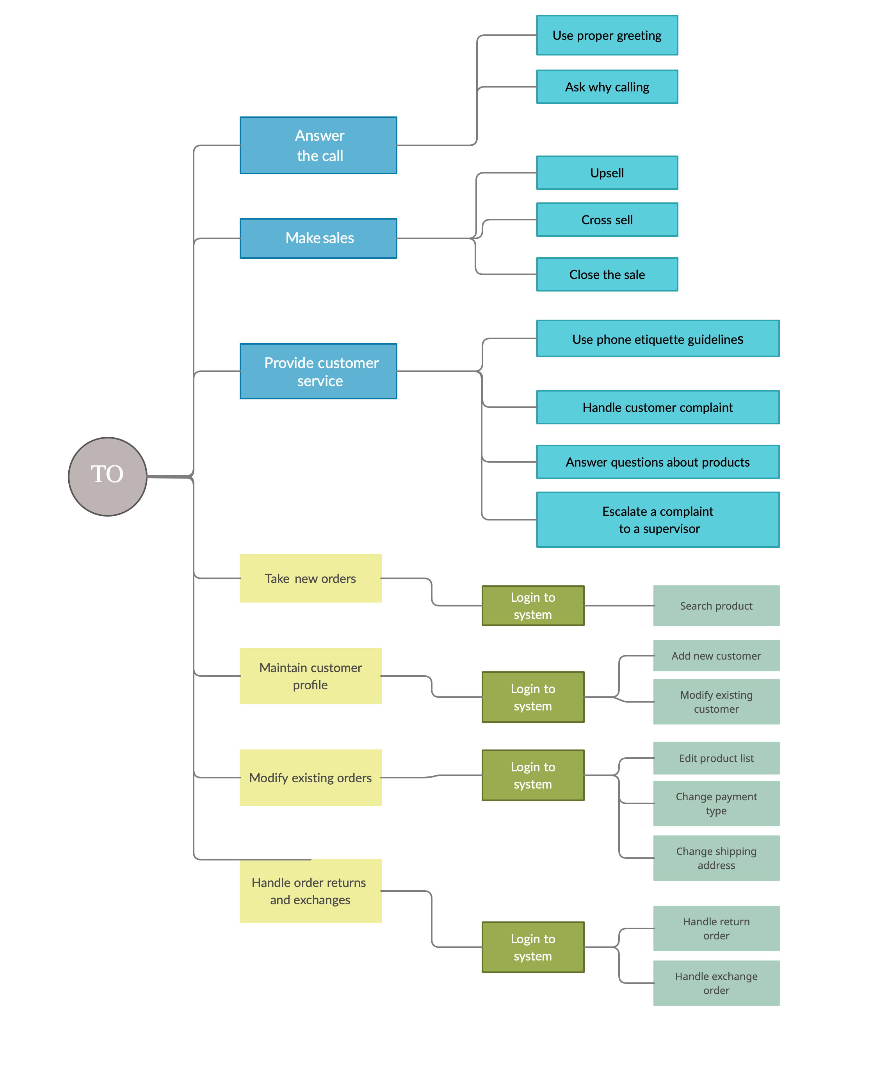
2. Module Flowchart
How to do product search 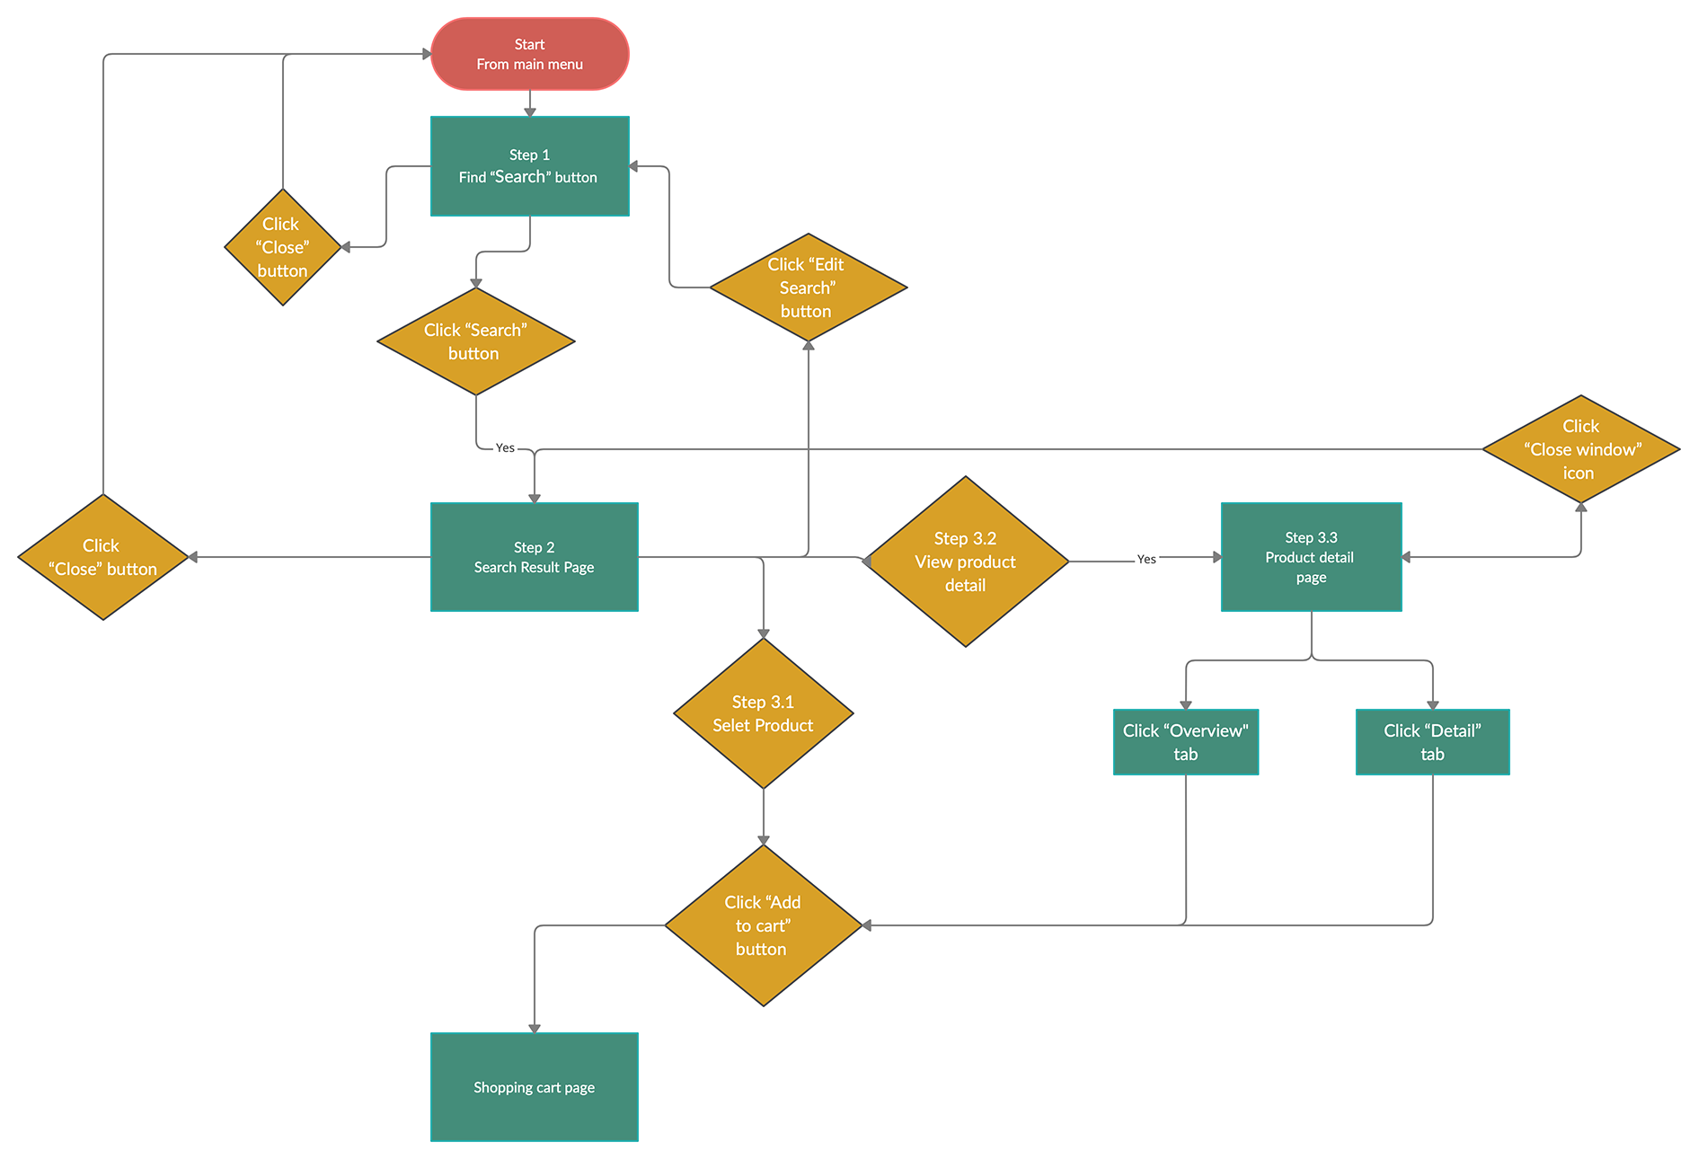

Appendix B: Detailed Course Outline [JW]
 | Mins. | Task / Topic / Key Concept | Objective | Instructional Method | Assessment Method | Assessment Description | Visuals / Media Support
I.  A-D | 15 mins. | Course Overview and Introductions (Customer Service)  - Course facilitators  - Participants  - Ice breaker  Purpose of workshop  - Objectives  Housekeeping  - Breaks  - Ground rules  - Parking lot | N/A | Present facts/ information | N/A | N/A | PowerPoint slides with text and graphics (graphic indicator)  Name tents for each participant  Icebreaker question:  If you had a time machine, would you go back in time or into the future?
V. A | 5 mins. | Module 4 – Handling Customer Complaints  - Lesson introduction  - Objective(s) | N/A | Present facts/ information | N/A | N/A | PowerPoint slides with text and graphics (graphic indicator highlighting this lesson)
V. B | 15 mins. | Using the HEAT strategy  - Hear the complaint  - Empathize  - Apologize  - Take ownership  - Finalize the call | Given a variety of scenarios, the learner will correctly use the HEAT guidelines to de-escalate the customer and respond appropriately to resolve the customer's issue | Present principles and guidelines.  Demonstrate using role play applying principles and guidelines. | N/A | N/A | PowerPoint slides with text; job aid for reference.
V.C | 30 mins. | Practice Exercises  Review strategy guidelines  Role-play scenario | (same as above) | Demonstrate using role play applying principles and guidelines  Checklist of guidelines to use in observing performers of task | Practice principles and guidelines with role play when given various scenarios  (formative assessment)  Use of checklist to identify use of guidelines while observing a role play | Role play of various common scenarios considered customer complaints. Participants will be placed in triads with one playing the role of the customer, one as the telephone operator, and one as the observer/coach. Roles will be rotated for each scenario so that every participant gets a turn playing each role. The coach and the operator roles will not be provided the customer’s script in each round.  Checklists will be provided to guide the observation and coaching.  Scenario 1: Item received broken on Christmas Eve  Scenario 2: Customer double charged for order  Scenario 3: Customer says order is not what was described in the catalog product details | Role play scripts; job aids; checklist for observer
V. E | 10 mins. | Review and Summary | N/A | Repeat information | N/A | N/A | Summary PowerPoint Slide with transition to next lesson
- A-D | 15 mins. | Course Overview and Introductions (SimplyOrder System)  - Course facilitators  - Participants  - Ice breaker  Purpose of workshop  - Objectives  Housekeeping  - Breaks  - Ground rules  - Parking lot | N/A | Present facts/ information | N/A | N/A | PowerPoint slides with text and graphics (graphic indicator)  Name tents for each participant  Workstations set up with SimplyOrder sandbox  Icebreaker question: If you could be any cartoon character, who would you be and why?
III.A | 5 mins. | Finding the Product in the SimplyOrder System  - Introduction  - Objective(s) | N/A | Present facts/ information | N/A | N/A | PowerPoint slides with text
III.D | 30 mins. | Searching for a product | Given a product, product number, product name, or keyword, the telephone operators and customer service supervisors will correctly find the product within 60 seconds. | Apply procedures  Demonstrate task using procedural steps  The facilitator will demonstrate using the search feature of SimplyOrder system using brand, category, price range, product number, product name, keyword or catalog period, or a combination of fields to narrow the search. | Application of procedure/  return demonstration | Participants will be provided product numbers, key words, and product name to search for the product in the SO sandbox (test system).  Examples:  CAN2345, 3-wick candle, white candle, $21-30 Magnolia candle  CAR4203, cardigan, sweater, $51-60, Irish knit cardigan (Ivory)  TUM2345, personalized tumbler, cup, personalized gifts, $31-40, Jeanne Creations galaxy tumbler | SimplyOrder system projected on screen.  SimplyOrder test system/sandbox  Student guide with screen shots
III.J | 10 mins. | Review and Summary | N/A | Repeat information | N/A | N/A | Summary PowerPoint Slide with transition to next lesson

Appendix C: Final Assessment [JW]
For this course, there will be no formal assessment. Instead, informal assessments will be included throughout the trainings which include practicing and applying customer service strategies, performing and demonstrating ordering procedures using a variety of exercises and role play scenarios. These formative assessments will include the use of checklists where observers can identify the participants’ success in achieving the task and following the procedure. A workshop evaluation will be distributed to participants at the end of the session as feedback to the presenters and instructional designers regarding the effectiveness of the course in the participant’s view. A post-workshop assessment will be conducted to measure the improvement in the performance of the participants on the job as determined by an increase in customer satisfaction, improved skills in handling customer complaints, an increase in sales, and proficiency in using the SimplyOrder system.

Appendix D: SimplyOrder System Screenshot

