Customer Service and SimplyOrder Training

© 2021 JKKL Consulting. All Rights Reserved.

Table of Contents
Instructor Information – [JW] iii
Content Introduction iii
Audience Information iii
Topics iv
Timeline iv
Preparation Checklist v
Unit 1: Class Overview – [JW] 1
Module 3: Handling Customer Complaints – [JW] 9
Introduction 9
Topic 1 -- Using the HEAT Strategy to Handle Customer Complaints [JW] 11
Unit 2: Class Overview: SimplyOrder Training – [KP] 22
Module 3: Finding Products in SimplyOrder System – [KP] 29
Introduction 29
Using Search Functionality 32

Instructor Information – [JW]

Content Introduction
This course is designed to improve the skill set of Happy Products & More (HP&M) Telephone Operators and Customer Service Supervisors so that they can better serve their customers. The training is divided into two parts – customer service skills and using the SimplyOrder system. The workshops are interactive using scenarios and practice exercises to allow for better on-the-job training transfer.

The customer service skills training is intended to equip employees with strategies and techniques to handle phone calls effectively and efficiently to improve the customer’s experience and interaction with HP&M. The telephone operators often form the customer’s first impression of the company, so having the customer’s interaction be positive is critical. The workshop will cover using scripts, de-escalating calls using the HEAT strategy, and handling calls that require supervisor intervention.

At the end of this workshop, the learner will be able to:

- use customer service scripts as guidance for various situations to provide consistent service
- use the HEAT method to de-escalate the customer and respond appropriately to the customer’s issue
- properly escalate calls to supervisor with smooth transitions

The SimplyOrder training is to teach the new system to the staff so that they can efficiently use it to find products, place orders, modify orders, cancel orders and increase sales through upselling and cross-selling. This workshop is hands-on with each participant having their own workstation to become proficient in the system’ use.

At the end of this workshop, the learner will be able to:

- log into the SimplyOrder system.
- search for a product using keywords, product name, product number, or other search-enabled identifiers
- utilize the components of the system to place a customer order.
- modify or add to an existing order for a customer.
- complete the return process for a customer.
- upsell and/or cross-sell products
- answer general questions from customers.
- exit out of the system.

Audience Information
The target audience for this training is the HP&M Telephone Operators and Customer Service Supervisors.

The general learner characteristics are females, between 18-60 years of age, high school diploma or equivalent, with a few having college hours. The average tenure is 1.9 years with the longest tenured operator being with the company three (3) years.

Entry orientation to the course: most have voiced dissatisfaction with their current work processes and the company culture. They feel previous training provided by HP&M is not beneficial. Many of the participants are out of their orientation period and have significant experience working with the current order entry system and the telephone system. Staffing is based on a 24/7 model with three shifts – day, evening, and night, therefore, the employees most likely do not work directly together with their peers attending the same workshop session.

As these are adult learners, it is important to remember that adults have a higher need to have the learning be practical and relevant. In this case, the training is intended to help them improve their job skills to be more successful on the job.

Topics
The topics covered in each workshop are broken into modules to allow for participants to learn the information, connect it to what they already know, and practice their skills.
Customer Service – Our Key to Success

Module 1 – Introductions and Overview
Module 2 – Using Scripts
Module 3 – Handling Customer Complaints
Module 4 – Putting it all Together (Review and Summary)

SimplyOrder Training

Module 1 – Introductions and Overview
Module 2 – Starting the SimplyOrder System
Module 3 – Finding Products
Module 4 – Placing an Order
Module 5 – Modifying or Adding to an Existing Order
Module 6 – Handling Customer Returns
Module 7 – Putting it all Together (Review and Summary)

Timeline
The workshops are each four (4) hours in length, with two 15-minute breaks to allow the participants to handle personal issues or phone calls. Snacks and beverages will be provided. The timeframes for each lesson activity are recommendations and should be modified based on the progress of the group.

Customer Service – Our Key to Success (4 hours) | Time in Mins. | Timing
Start time |  | ___:___
Module 1 – Introductions and Overview | 20 | ___:___ to ___:___
Module 2 – Using Scripts | 60 | ___:___ to ___:___
Break | 15 | ___:___ to ___:___
Module 3 – Handling Customer Complaints | 75 | ___:___ to ___:___
Break | 15 | ___:___ to ___:___
Module 4 – Putting it all Together (Review and Summary) | 45 | ___:___ to ___:___
End time |  | ___:___
SimplyOrder Training
Start time |  | ___:___
Module 1 – Introductions and Overview | 20 | ___:___ to ___:___
Module 2 – Logging-In and Exiting SimplyOrder | 15 | ___:___ to ___:___
Module 3 – Search for Product Information in SimplyOrder | 60 | ___:___ to ___:___
Break | 15
Module 4 – How to Place a New Order | 30 | ___:___ to ___:___
Module 5 – How to Modify or Add to an Existing Order | 30 | ___:___ to ___:___
Break | 15
Module 6 – How to Handle Returns and Exchanges | 30 | ___:___ to ___:___
Module 7 – Putting it all Together (Review and Summary) | 45 | ___:___ to ___:___
End time |  | ___:___

Preparation Checklist

This checklist is intended to help you be prepared for the class and to ensure an enjoyable experience for the participants. The training will be conducted in the HP&M training room, which is equipped with tables, chairs, a projector, screen, telephone, flip charts and computer workstations. Any additional supplies needed can be obtained from the HP&M Office Coordinator. The IT Help Desk is also available for any technical assistance. Their phone number is (985) 280-8888. Contact Environmental Services (985) 280-5555 for any environmental issues (room temperature, etc.).

Customer Service Training

One Week Prior to Workshop

- Review facilitator guide. Make notes of areas you have questions about or need clarification. Also note where you want to emphasize a concept or have an idea for an example.
- Review the PowerPoint Slides for flow and navigation.
- Communicate with the IT department regarding the equipment set-up (projector, screen, clicker, etc.)
- Review the break-out group activities.
- Ensure that you have enough copies of all scripts needed for role-play exercises.
- Have other supplies ready: markers, flipchart, Post-It notes, masking tape, etc.

Day Before Class

- Gather all materials needed for class:
  - Student guides
  - Pen or pencil, notepads, name tents, markers for tables, Post-it Notes for tables
  - Attendance roster
  - Sign-in sheet
  - Evaluation forms
- Ensure tables are arranged in a U-shape with extra chairs in four areas away from the table for roleplay exercises

Day of Class

- Arrive at least 60 minutes early
- Load and test PowerPoint
- Have “Welcome” slide showing as people arrive
- Place sign-in sheet at the table with a pen
- Place student guides, pens, notepad and name tent at each participant’s seat
- Post Parking Lot and Ground Rules flip charts.
- Place flipchart at front of the room.
- Optional: Have appropriate music playing as participants arrive.

SimplyOrder Training

One Week Prior to Workshop

- Review facilitator guide. Make notes of areas you have questions about or need clarification. Also note where you want to emphasize a concept or have an idea for an example.
- Review the PowerPoint Slides for flow and navigation.
- Communicate with the IT department regarding the equipment set-up (projector, screen, clicker, etc.)
- Sign-in to SimplyOrder sandbox and familiarize yourself with the navigation.
- Review and test the practice exercises.
- Ensure that you have enough copies of all practice exercises for participants.
- Have other supplies ready: markers, flipchart, Post-It notes, masking tape, etc.
- Arrange for IT tech to meet you when you arrive day of class for final equipment check.

Day Before Class

- Gather all materials needed for class:
  - Student guides
  - Pen or pencil, notepads, name tents, markers for tables, Post-it Notes for tables
  - Attendance roster
  - Sign-in sheet
  - Evaluation forms
- Test each workstation to ensure that the sandbox is accessible and ready for use. If there are any issues, contact IT immediately.

Day of Class

- Arrive at least 60 minutes early
- Have workstations are turned on and ready for log-in
- Load and test PowerPoint
- Have “Welcome” slide showing as people arrive
- Place sign-in sheet at the table with a pen
- Place student guides, pens, notepad and name tent at each participant’s seat
- Post Parking Lot and Ground Rules flip charts.
- Place flipchart at front of the room.
- Optional: Have appropriate music playing as participants arrive.

Unit 1: Class Overview – [JW]
Time: _20__ min.
Show the first PowerPoint slide as participants enter the room.  Greet each person and introduce yourself.  Play music. You might want to have music playing as it sometimes makes the participants more comfortable as they are waiting for the class to begin. |  | 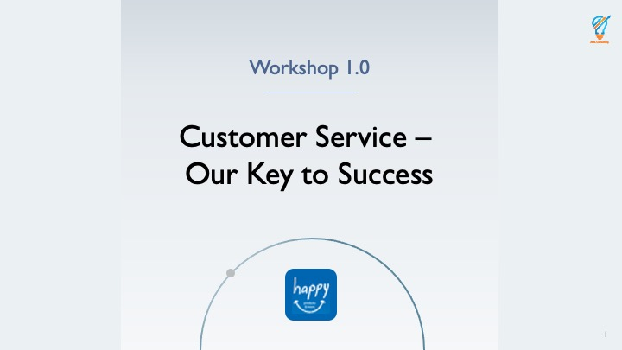
Show PowerPoint slide titled “1.1 - About the Workshop and Guidelines – Training Workshop”  Greet learners and welcome them to the Customer Service Training class.  Inform learners they will be acquiring knowledge about providing better customer service and handling customer complaints and the entire session will take four hours.  Circulate sign-in sheet.  Inform learners of where closest restroom are to classroom.  Inform learners there will be two 15-minute breaks during the course.  Inform learners questions are welcomed any time during training session.  Inform learners they will have time for role-play practices after each demonstration. |  | Welcome  Thank you for coming to the HP&M Customer Service training. HP&M’s goal is to be the leader in product and customer service. This training will introduce you to some techniques you can use to improve customer satisfaction. Once you’ve completed this interactive four-hour training, you will be able to easily handle customer calls and hopefully have less stress!  - Please make sure you sign-in on the sign-in sheet as proof of attendance and print your name next to your signature.  - Instructor points to location of nearest restrooms.  - The Customer Service Training will have two 15-minute breaks during the four-hour session.  - Questions are welcomed at any time during the training.  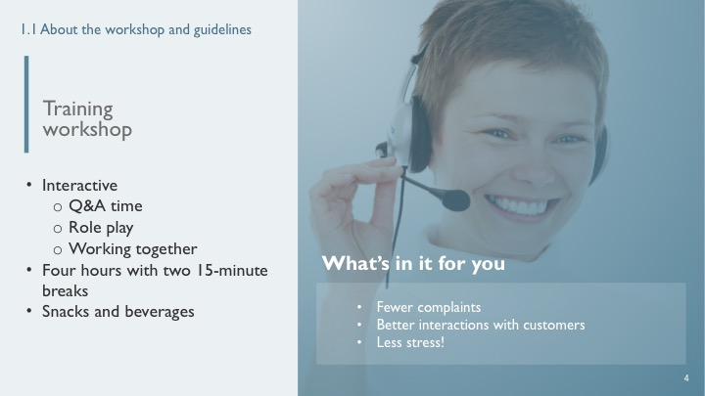
Show PowerPoint slide “1.1 -- Our Guidelines for Today’s Workshop”  Explain that these are the ground rules you will follow to ensure the workshop is an enjoyable experience.  Show the flipchart with the words “Parking Lot” on it. Explain that any ideas that need to be addressed that are a bit off topic will go to the parking lot to be reviewed at the end of the workshop.  Explain the guide is theirs to keep and use for future reference. |  | Ground Rules  In order to make our workshop a great experience for everyone, we will use these guidelines or ground rules. Read the slide and ask for their agreement in following the rules.  You will find Post-It notes in your working materials. Feel free to put any questions or concerns you have on a note and stick it in the parking lot. We will review those at the end of the workshop to make sure we have covered any open issues.  The Participant Guide is yours to keep and for you to make any extra notes during the workshop. Copies of all of today’s slides are in the guide for your reference.  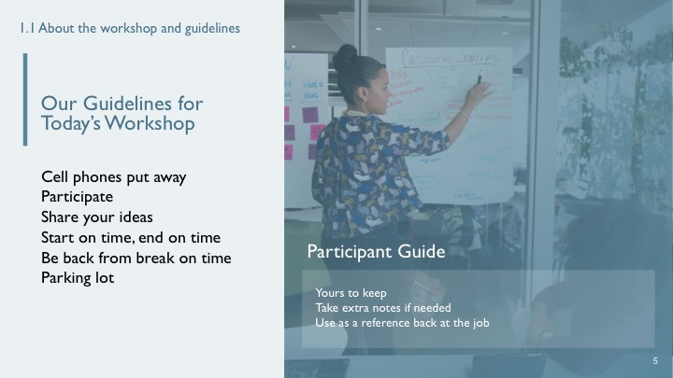
Show PowerPoint slide “About Us.” |  | Introduce Training Team  State who you are and allow the other team members/trainers to introduce themselves.
Show PowerPoint slide titled “1.1 -- Introductions.”  Introduce yourself including your name, position at HP&M, and background information about education and work history.  Ask learners to introduce themselves and state their name, position at HP&M, and background information about education and work history. Start with back of room and work forward.  Facilitate Ice Breaker question: “If you had a time machine would you go back in time or into the future?” Start with front of room and work backward. |  | Introductions  I’m (State your name, position, and background information.).  Now, it’s your turn to introduce yourselves. Let’s start in the back of the room and work our way forward.  Let’s complete a quick ice breaker question to get to know each other better. I’ll start: Answer question “If you had a time machine would you go back in time or into the future?”  Okay, how about we start in the front of the room answering this question and go backwards from there.  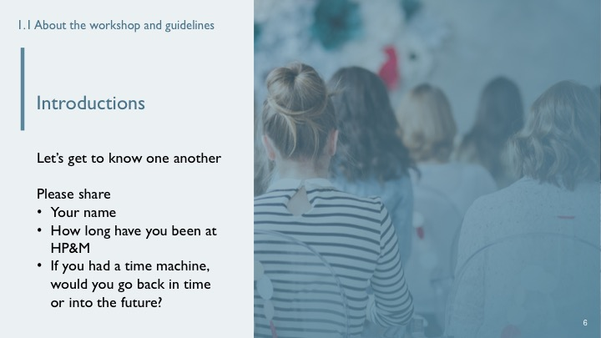
Show PowerPoint Slide titled “01 – Introduction.”  Cover purpose of customer service and SimplyOrder training.  Highlight that the new system was developed in response to feedback from Telephone Operators having difficulty finding product information on previous system.  Include that this system is meant to help improve customer and employee experience. |  | Purpose of Training  This workshop is the first of two workshops. This workshop with provide you with skills needed to help the organization improve customer service, and to help you better handle customer complaints. The second workshop will focus on using the new SimplyOrder system.  The customer service workshop was designed in response to customer feedback regarding their experience in calling HP&M.  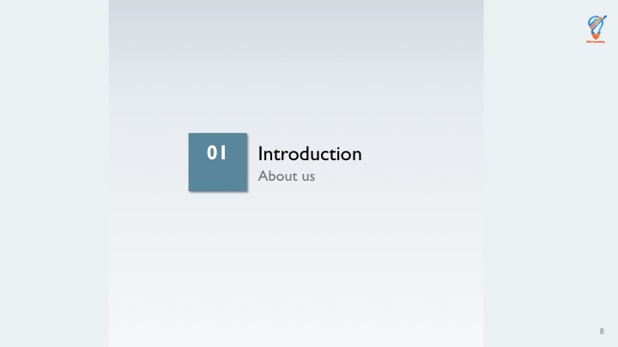
Show PowerPoint slide titled “Contents.”  Inform learners about the organization of the training and agenda.  Describe modules briefly and stress that each module will involve hands-on practice and assessments. |  | Agenda for the Class  The workshops begin with an introduction and overview of the workshop.  In Module 2, we will learn and practice using scripts.  Module 3 will focus on handling customer complaints, again with practice and using scripts.  And in Module 4, we will put it all together by practicing taking calls and reviewing what we have learned.  If at any time you have questions or concerns, please let me know by raising your hand.  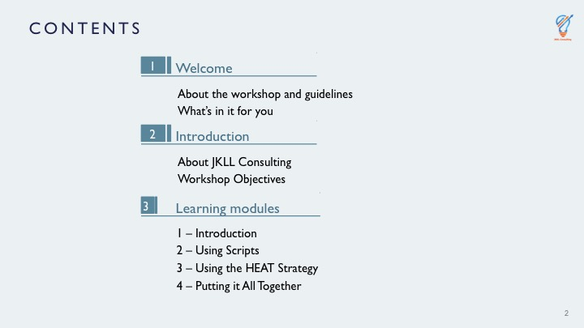
Show PowerPoint slide titled “Course Objectives.”  Inform learners of the course objectives. |  | Course Objectives  - Use customer service scripts as guidance for various situations to provide consistent service.  - Use the HEAT method to handle customer complaints.  - Properly escalate calls to supervisor with smooth transitions and minimal wait times.  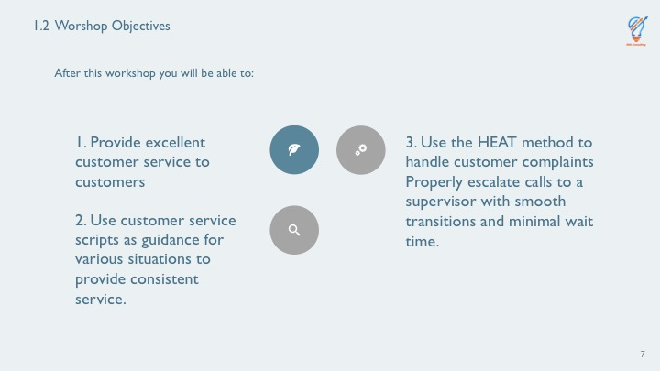
Ask learners if they have any questions to this point. |  | Questions  What questions do you have before we begin?

Module 3: Handling Customer Complaints – [JW]
Time: _60__ min.

Introduction

Show PowerPoint slide “Module 3 – Handling Customer Complaints” |  | Introduction  So far, we’ve talked about using scripts to streamline customer calls, and how our tone can translate even through the call. Now let’s talk about those “not so pleasant” calls that we receive where the customer is unhappy with the product or has an issue with their order.  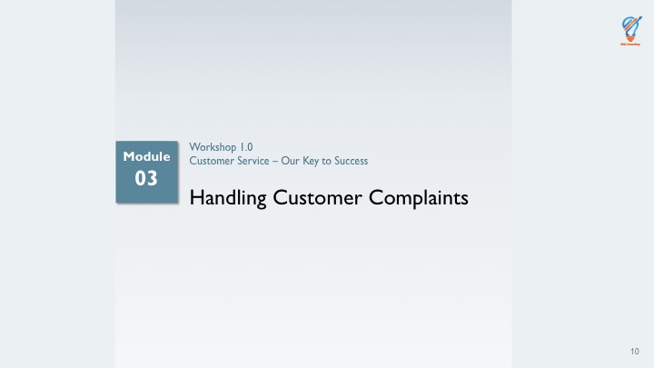
Show PowerPoint slide “3.1 – Overview”  Review the main topics of this module: the HEAT strategy and call escalation procedures.  Remind participants that we will be using role play to help practice using these skills.  Explain what’s in it for the participants and how it relates to the company’s success. |  | Overview  In this module we will look at the HEAT strategy to help you better handle customer complaints. We will also discuss when and how to escalate a call to a supervisor.  Importance  Handling customer complaints is one of the most significant parts of your job. Doing it well is critically important to the customer, the company, and for yourself.  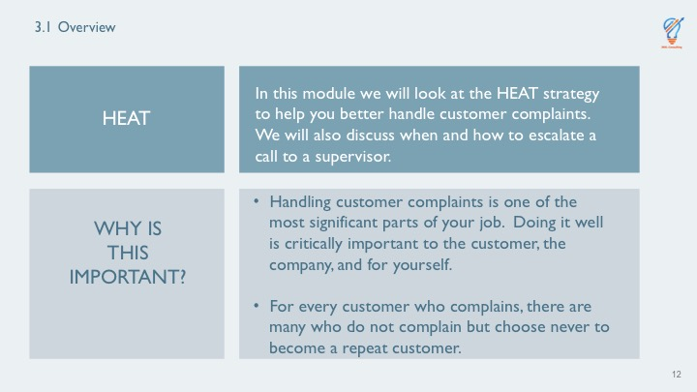
Show PowerPoint Slide “3.1 --Overview.”  Read the slide to the participants |  | Objectives  In this lesson, you’ll:  - Be able to use the HEAT guidelines to de-escalate the customer and respond appropriately to the customer’s issue.  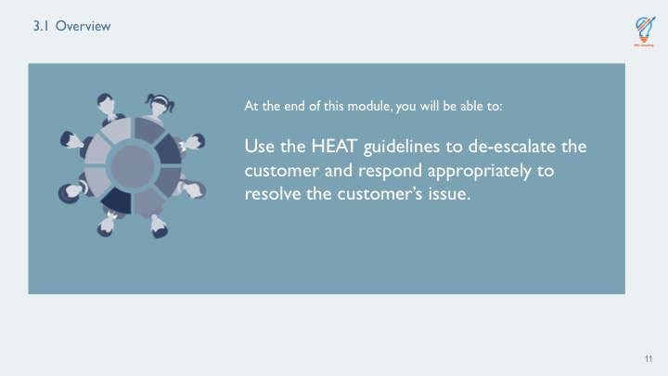

Topic 1 -- Using the HEAT Strategy to Handle Customer Complaints [JW]
Show PowerPoint slide titled “3.2 - Learning Objectives.”  Explain when that complaints are a means of bringing a problematic area to the attention of the company. |  | Introduction  No matter what business you are in, you will receive complaints. It is how you handle the complaints that make a difference. When a customer complains, they are attempting to highlight a problem with either the product, a person, a policy or a system, or perhaps a process.  Instead of thinking negatively about complaints we should realize that we are receiving feedback that the customer’s expectations have not been met.  A customer complains because they want a solution to the problem, so that should be our goal – to resolve the issue that the customer has identified and brought to our attention.  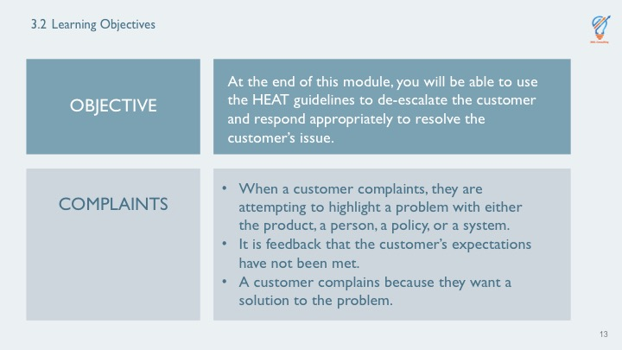
Show PowerPoint Slide “3.2 - Complaints.” There are three key points on this slide. Each point is animated to appear on click.  Click to show first point.  Click to show next point. Focus the participants’ attention on changing their paradigm from complaints as a negative to a means of getting information for improving service  Ask what are the most common reasons customers complain?  Ask for a list of the most common complaints. Write the list on a flipchart as the participants answer.  Ask what does the customer expect?  Show the last bullet on the slide. |  | Customer Complaints  We often think of complaints as a negative event. However, if we change our perspective, we might realize that the customer has a valid point, and we can use the complaint as feedback. We will never totally be able to avoid complaints, but we can make a difference in the way we handle the complaint.  When a customer has a complaint, they expect you to resolve it.  What are some common complaints you hear from customers?  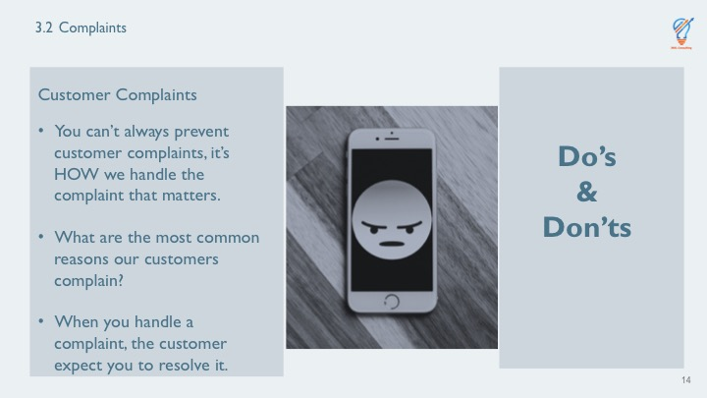
Show PowerPoint slide “3.3 HEAT Strategy.”  Explain what each letter in the acronym means.  This slide has built-in animation so that each letter of the acronym appears one at a time. You will leave this same slide up for the next four training points. |  | HEAT Strategy  Using the HEAT Strategy means we:  Hear the complaint  Empathize with the caller  Apologize for what they have experienced  Take ownership to resolve the problem  Let’s look at each one in detail  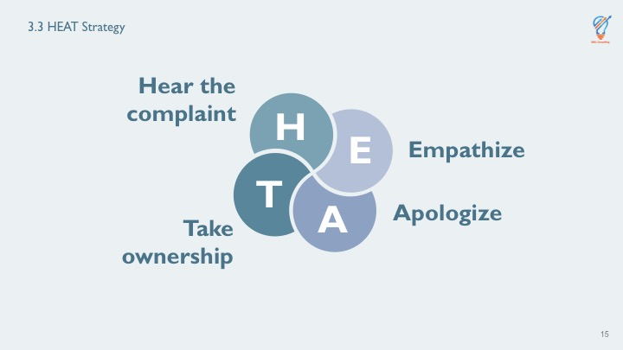
Show PowerPoint side “3.3 -- HEAT Strategy – Hear the Complaint.”  Read the bullets and explain why listening is important.  Example: You may want to use this example of not listening: “Ms. ummm… Smith. What did you say arrived broken?”  Ask what some ideas are of how you can better focus on what the customer is saying.  Record the answers on the flipchart.  Ask the participants what questions they have before moving forward. |  | H - Hear the Complaint  When listening to the customer, it’s important that we follow these guidelines:  Don’t interrupt. Let the customer say what they need to say.  Listen closely. We often formulate our response while the other person is speaking instead of listening to what they are saying.  Don’t become defensive. Being defensiveness may only make the customer more agitated.  Stay calm – as we mentioned in the previous section, your tone is reflected in your words and your voice. It is understandable that it will be hard to remain calm if the customer raises their voice or uses inappropriate language but keeping your cool will go a long way toward diffusing the situation.  Stay focused and don’t jump to conclusions.  Use their formal name when speaking with them to help them know you are listening to them as an individual. Use Ms. or Mr. (last name) whenever possible. For example, you might say “I understand what you are saying, Ms. Jones.”  What are some other examples of how you can show you are listening?  What are some ideas of how you can focus on what the customer is saying?  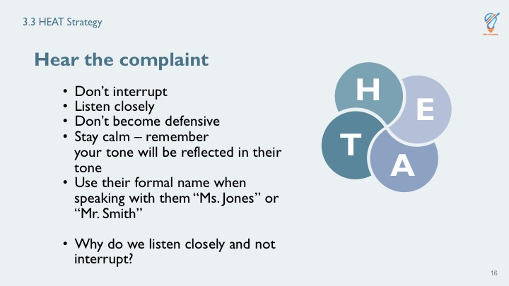
Show PowerPoint side “3.3 -- HEAT Strategy - Empathize.”  Explain the second step in the HEAT strategy is to empathize with the customer.  Suggested answer: for empathy versus sympathy -- empathy goes a step further than sympathy in that you are not just feeling bad for the person, but you care about and can relate to the other person’s experiences.  Ask the participants to share the last time they had a problem with a product or service. How did they feel? What did they do?  Look for commonalities in the answers and paraphrase them before moving on.  Ask “is this statement empathetic? I hear what you’re saying, but I’m not sure I can handle this problem.”  Ask “what is wrong with what I just said?”  Allow time for responses.  Prime if necessary, by restating the example.  Ask “how could we change what I said to show empathy?”  Ask the participants what questions they have before moving forward. |  | E – Empathize  What does the word empathize mean? How is empathize different than sympathize  This requires that we put ourselves in their position to understand their frustration and concerns. If we become defensive, we are not respecting them or acknowledging their issues. A great technique to empathize is to paraphrase what they have said – this shows we are listening and can relate to them.  If a customer calls about an item that was received broken, we might say, “Ms. Jones, you’re saying that the item was received broken. I understand your frustration.”  Notice how this statement paraphrases what the customer might have said and validates her feelings.  This technique can also be used to clarify what the customer has said to ensure you are responding to the correct issue.  You may want to take a deep breath before answering the call especially if you have dealt with several irate customers already during your shift. This customer doesn’t know that you’re having a bad day. They only know THEY’RE having a bad day.  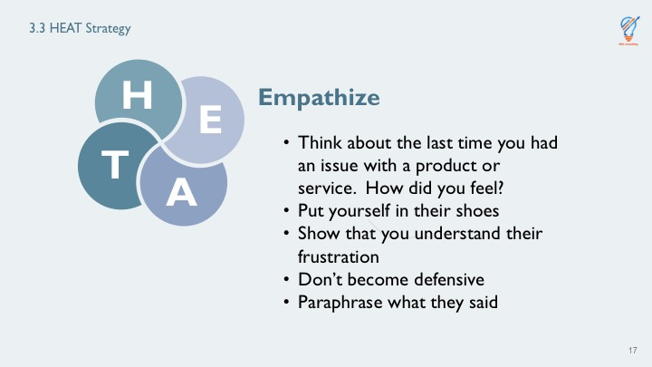
Show PowerPoint side “3.3 -- HEAT Strategy - Apologize.”  Explain that apologizing allows the customer to feel that the company is willing to take responsibility for ensuring the customer’s satisfaction with their products or service. This can also help gain the customer’s trust so that they would be willing to purchase from HP&M in the future.  the participants to read the statement and rate it from 1 to 5 with 1 being terrible and 5 being excellent: “I’m sorry for the inconvenience.” Ask for their responses. The suggested rating is a 2.  Explain that according to call center customer service experts, the term “inconvenience” creates distance and minimizes the possible impact of the problem on the customer.  Ask the participants what questions they have before moving forward.  Recap the first three steps of the process then move to the next slide. |  | A – Apologize  Most likely you are not the source of the customer’s frustration; however, you are the person who can resolve their issue. A simple “I’m sorry” goes along way. You might think “they’re yelling at me and it’s not my fault the vase was broken.” But saying “it’s not my fault” will not help with their anger. When people are angry, they are not rational. Staying calm and apologizing may bring help take the emotion out of the discussion. Make sure you sound sincere in your apology.  Take care that you don’t inadvertently blame someone else in an attempt to help the customer by saying something like “I’m sorry. I understand. Our shipping department is really slow” or “I know the post office is all backed up with deliveries. I’m sure your package is sitting somewhere in a warehouse.”  Here’s a tough situation: What if the item was damaged by the post office? How would you respond to the customer?  Proper response: HP&M pays for insurance on all packages. We will replace the item for the customer.  On a scale of 1 terrible to 5 excellent, rate this apology:  “I’m sorry for the inconvenience.” Your rating _____  We have covered Hear the complaint, Empathize, and Apologize, now we will bring in the fourth step of the HEAT strategy.  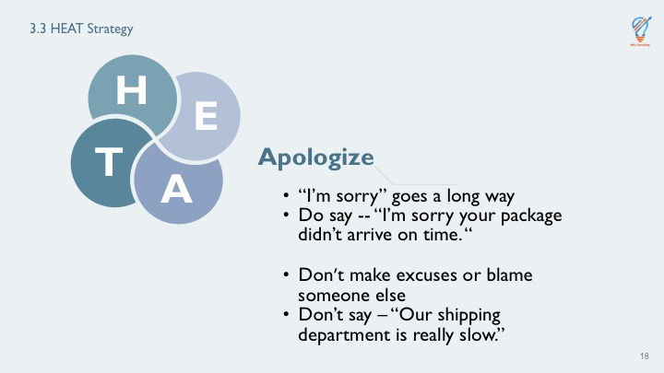
Continue to Show PowerPoint side “3.3 -- HEAT Strategy.”  Explain that taking ownership means that you are committed to resolving the customer’s issue. It is also important that you communicate clearly what actions you will take to ensure the customer is satisfied with the resolution.  Additional information - You may want to have a copy of the service recovery policy on hand to review if needed.  Read the “let’s suppose” scenario. Allow time for participants to respond to the scenario.  Say “One final tip on HEAT – avoid putting the customer on hold if at all possible. Putting them on hold only adds to their frustration.”  Ask participants if they have any questions.  Say “Now let’s put everything together by practicing the HEAT strategy” before clicking to the next slide. |  | T – Take Ownership  This is the most important element of the HEAT strategy. Taking ownership means that you take action to resolve the problem. This might mean replacing the product, refunding their money, or some other action. You are empowered by company policy to do what is needed to fix the problem. If you have any questions about it, refer to your quick reference manual on service recovery.  The final step is to convey to the customer what you are going to do and ask their approval. If they are still not satisfied and you have exhausted all possible solutions, you may need to have your lead operator intervene. We will cover that in the next lesson. However, handing-off the customer should be a last resort.  Let’s suppose you’ve had a really bad day. You are tired because your child was ill during the night. Your dog got out and you had to chase it down the street. Then you got stuck in traffic. The first customer calls and starts yelling about the scarf they purchased being too “flimsy.” Your first instinct is to say, “That’s not a problem. Let me tell you about my problems. Instead, what should you do?  Apologize again and reiterate what you are doing to resolve the problem.  Here’s another example, “I’m sorry, Ms. Jones, that your vase was received broken. We have another one like it in stock and I will have it shipped to you today. We value your business and thank you for calling to let us fix this situation. Is there anything else I can do for you?”  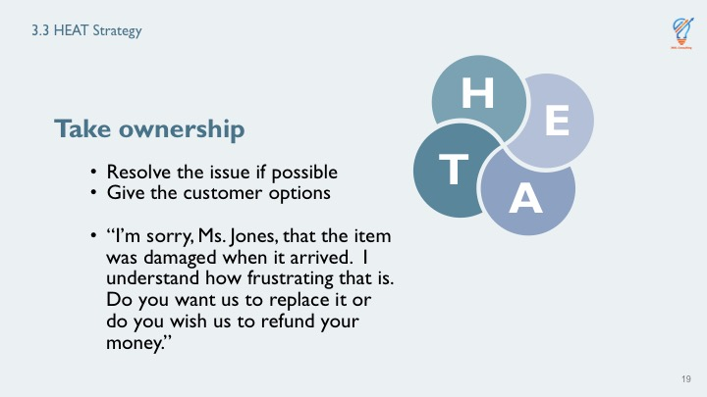
Show PowerPoint slide “Practice Exercise.”  Scripts are provided below. Hard copies of customer scripts and observation checklists are provided in your packet of copies. Hold the scripts until you are ready for each round of practice.  Make sure each triad has a customer, TO, and observer. Hand out the appropriate sheet for the role the person is playing.  Scenario 1: Item received broken on Christmas Eve.  Script: “I’m very angry right now. I ordered this angel for my mother three weeks ago, and it finally arrived today, and the wings are broken. How can I give her a broken angel? She’s 87-years-old and this is what she really wanted for Christmas.”  Scenario 2: Customer double charged for order.  “I just got my credit card bill and I saw I was charged twice for the items I ordered. That’s $273.00 that I really don’t have to spare.”  Scenario 3: Customer says order is not what was described in the catalog product details.  “I ordered a navy-blue scarf with gold trim to wear to a Mardi Gras ball. There is no way I can use this scarf. It’s not navy blue. It’s some weird color that doesn’t match anything in my closet. I clearly asked the operator when I ordered it if it was navy blue, and she said, ‘yes.’ “  Circulate and observe each group to ensure they are following the script and instructions. | 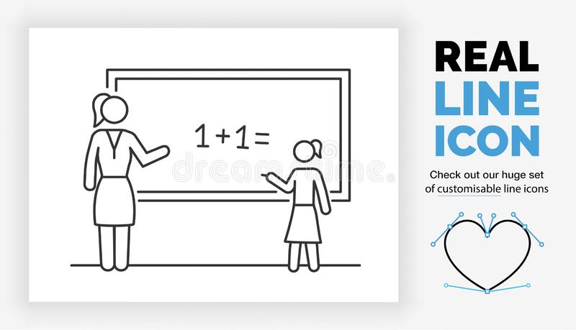 | Putting it All Together – HEAT Let’s Practice  We will break into groups of three. Identify one person to be the customer, one to be the telephone operator, and one person as an observer. We will rotate these roles as we will have three practice rounds.  Telephone operators -- just like when you are taking calls, you won’t know why the customer is calling.  Customers – the operator won’t know why you’re calling until you start talking.  Observers – you are a fly on the wall. You can’t intervene – just watch and listen. Make notes of what the operator does well and note as they use the HEAT strategy.  Customer -- Read over your script, but don’t let the operator or observer see it.  I’ll give you an example of how we’re going to do this: The caller calls and says they didn’t get one of the items in their order and they need it by Friday. How would I use HEAT?  “I’m sorry, Mr. Snaggle, that you didn’t receive the train set. I can understand your concern since you said it’s for your nephew’s birthday on Friday. What if I express mail a new train set to you that you should receive in 2 days? If the other train set shows up, you can send it back to us by putting “Return to Sender” on the package and leaving it for the carrier.”  How did I do using the HEAT strategy?
Show PowerPoint slide “Handing Customer Complaints”.  Ask these questions, pausing for answers.  Elaborate as needed and make connections between participants’ answers.  Thank them for participating and congratulate them on doing well with their role play.  Ask what questions they have before moving on. |  | Debrief, Review and Summary  How did it go with your responses and using HEAT?  Which scenario was the most difficult?  Customers, did you feel the emotion as you were sharing the problem?  Operators, how did you feel using HEAT?  Observers, how hard was it not to intervene?  Don’t worry, before long with practice HEAT will become second nature.  Hand out HEAT magnets that they can put on their workstation.  Okay, let’s move on to the next topic – escalating calls to a supervisor.
Continue to show the HEAT Strategy slide.  Say “Remember, hear the complaint, empathize, apologize and take ownership.”  Transition into the break by thanking the learners, reminding them that the break is 15 minutes, and asking them to be sure to return on time so that we can stay on track. Give them a specific time to return by stating the current time (by your watch or the clock, etc.) and what time they should return. |  | Review and Summary

Unit 2: Class Overview: SimplyOrder Training – [KP]
Time: _20__ min.
Show the first PowerPoint slide as participants enter the room.  Greet each person and introduce yourself.  Play music. You might want to have music playing as it sometimes makes the participants more comfortable as they are waiting for the class to begin. |  | Opening Workshop  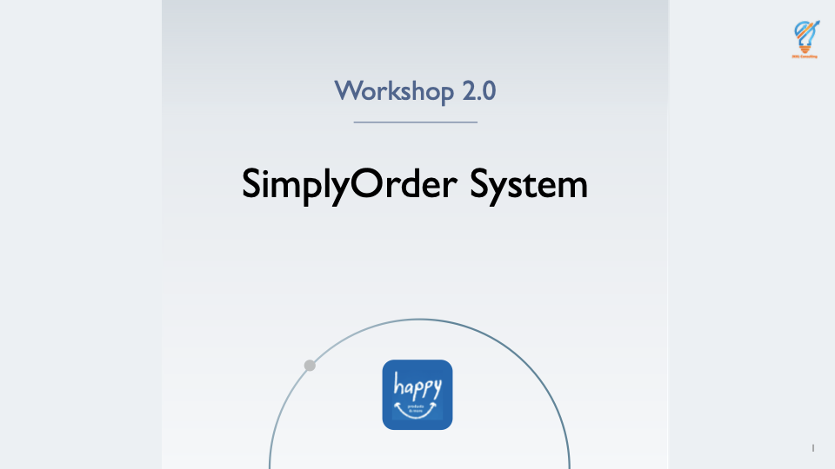
Show PowerPoint slide titled “Contents.”  Greet learners and welcome them to the SimplyOrder Training class.  Inform learners they will be acquiring knowledge about the new ordering system and the entire session will take four hours. |  | Welcome  Thank you for coming to the SimplyOrder training. This training will introduce you to the new ordering system that is being implemented at Happy Products and More. Once you’ve completed this four-hour training, you will be able to easily use the new system.  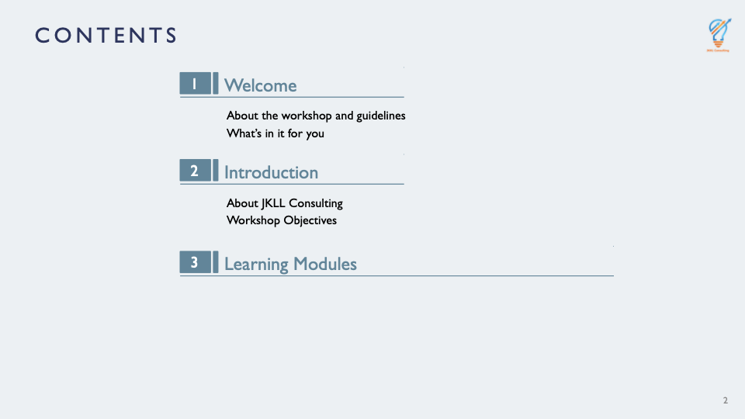
Keep up PowerPoint slide titled “Contents.”  Cover purpose of training.  Highlight that the new system was developed in response to feedback from Telephone Operators having difficulty finding product information on previous system.  Include that this system is meant to help improve customer and employee experience. |  | Purpose of Training  The purpose of the SimplyOrder training is to introduce you to the new system and give you hands-on practice. This will help you gain the knowledge and skills needed to use SimplyOrder to efficiently and easily find product information, take orders, and handle returns and exchanges.  This new system was developed in response to feedback from all of you regarding all the trouble you were having with the previous system. In addition, this new system and your training are meant to help improve both your experience and that of the customer.
Show PowerPoint slide titled “Welcome.”  Introduce yourself including your name, position at HP&M, and background information about education and work history.  Ask learners to introduce themselves and state their name, position at HP&M, and background information about education and work history. Start with back of room and work forward.  Facilitate Ice Breaker question: “If you could be any cartoon character, who would you be and why?” Start with front of room and work backward. |  | Welcome and Introductions  I, as your instructor, will introduce myself first. (State your name, position, and background information.)  Now, it’s your turn to introduce yourselves. Let’s start with everyone who was born in January and go chronologically to December.  Let’s complete a quick ice breaker question to get to know each other better. I’ll start: Answer question “If you could be any cartoon character, who would you be and why?”  Okay, how about we start with folks born in January.  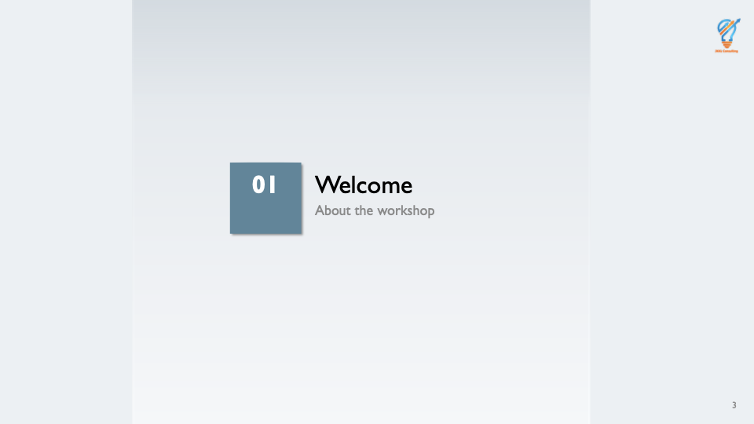
Show PowerPoint slide titled “1.1 About the workshop and guidelines.”  Circulate sign-in sheet.  Inform learners of where closest restroom are to classroom.  Inform learners the entire training will be four hours and include two fifteen-minute breaks.  Remind learners refreshments are provided during breaks.  Inform learners questions are welcomed any time during training session.  Ask learners to be attentive during demonstrations on new ordering system.  Inform learners they will have time for hands-on practices after each demonstration and the participant guide is theirs to keep. |  | Administrative Details  I will cover the following administrative details for this training.  - You, as learners, are required to place signature on sign-in sheet as proof of attendance.  - Instructor points to location of nearest restrooms.  - The SimplyOrder Training will have two 15-minute breaks during the four-hour session.  - Questions are welcomed at any time during the training.  - You will have ample opportunity for hands-on practice with the new system after each demonstration done by the instructor.  - You can keep the participant guide. Please mark it up as you see fit with notes and reminders to later use as a reference guide on the job.  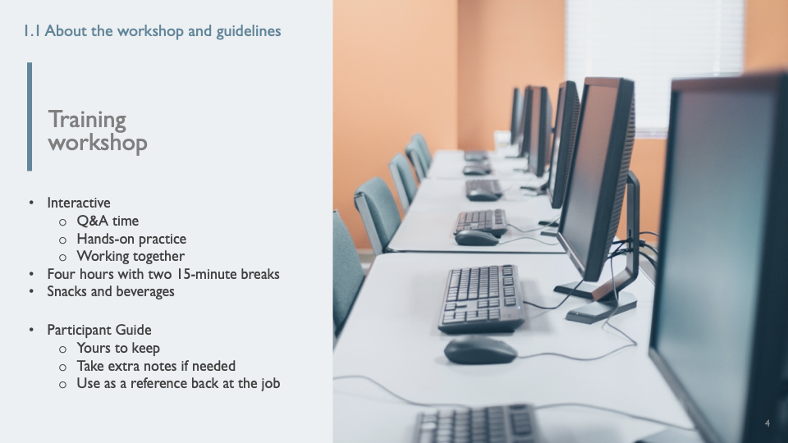

Show PowerPoint slide titled “1.2 Course Introduction.”  Announce reasons for the SimplyOrder training.  Explain what learners will get out of the session. |  | Course Introduction  This training is designed to help you gain knowledge of features, functions, and procedures of SimplyOrder system so you can complete the following tasks:  - Logging in and exiting the system  - Searching product information  - Placing a new order  - Modifying or adding to existing orders  - Handling returns and exchanges  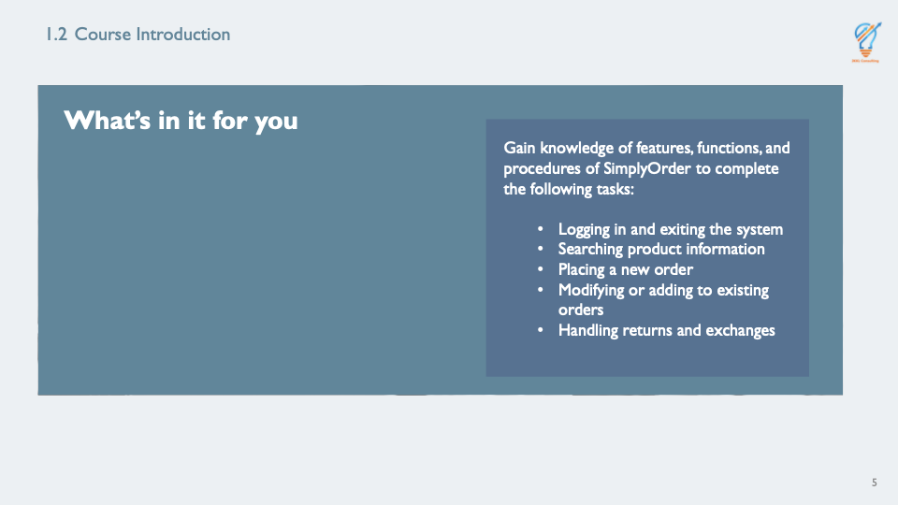

Show PowerPoint slide titled “1.3 Course Objectives.”  Inform learners of the course objectives. |  | Course Objectives  Upon completion of the SimplyOrder training, you will be able to:  - Access SimplyOrder system (logging on and exiting)  - Find specific products quickly and efficiently  - Complete process to place a new order  - Complete process to modify or add product(s) to an existing order  - Explain return or exchange process to customer and carry out procedure  - Handle general questions from customers  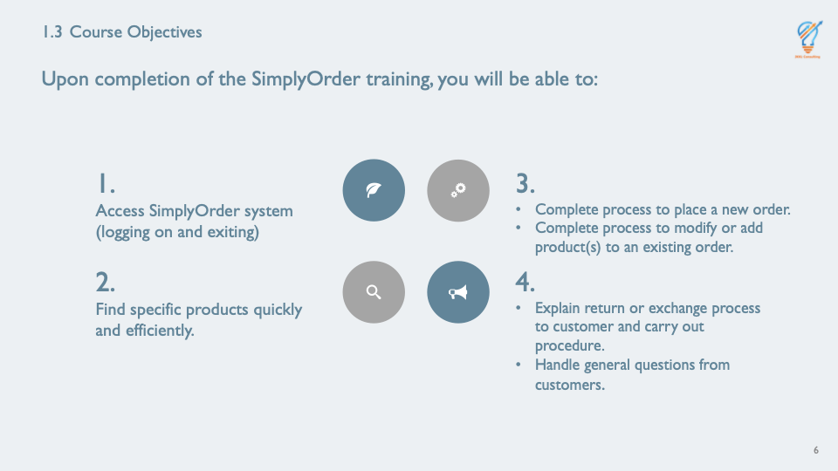

Show PowerPoint slide titled “1.4 Course Organization and Agenda.”  Inform learners about the organization of the training and agenda.  Describe modules briefly and stress that each module will involve hands-on practice and assessments. |  | Agenda for the Class  This course is the second of two classes designed for Telephone Operators and Customer Service Supervisors. It begins in Module 1 with a brief introduction and overview of the course.  You will learn about the new features and various functionalities of SimplyOrder which will be covered in five modules broken into topics listed below:  - Module 2: Logging-In and Exiting SimplyOrder  - Module 3: Search for Product Information in SimplyOrder  - Module 4: How to Place a New Order  - Module 5: How to Modify or Add to an Existing Order  - Module 6: How to Handle Returns and Exchanges  Each module will include hands-on practice and assessments. Module 7 is where we will wrap it all up in a review and summary followed by a question-and-answer session.  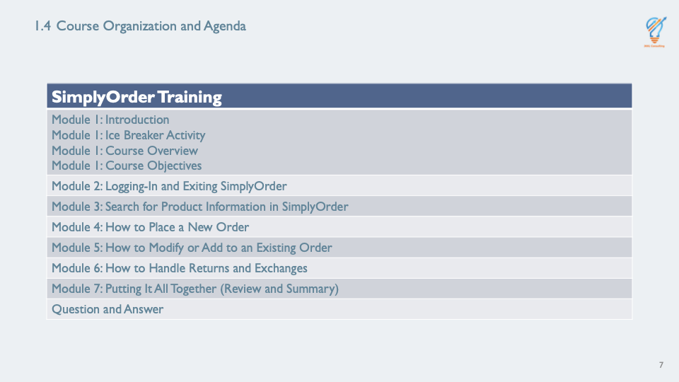
Ask learners if they have any questions to this point. |  | Check-In  What questions do you have thus far?

Module 3: Finding Products in SimplyOrder System – [KP]
Time: _60__ min.

Introduction
Show PowerPoint slide titled “Module 3: How to Search Product Information in SimplyOrder.”  Inform learners searching for and retrieving product information efficiently is an essential step in accurately taking orders for customers. |  | Introduction  Before you take new orders from customers, it is essential to search for the desired product and its related information. This module will guide you through the various ways you can search for product information in SimplyOrder.  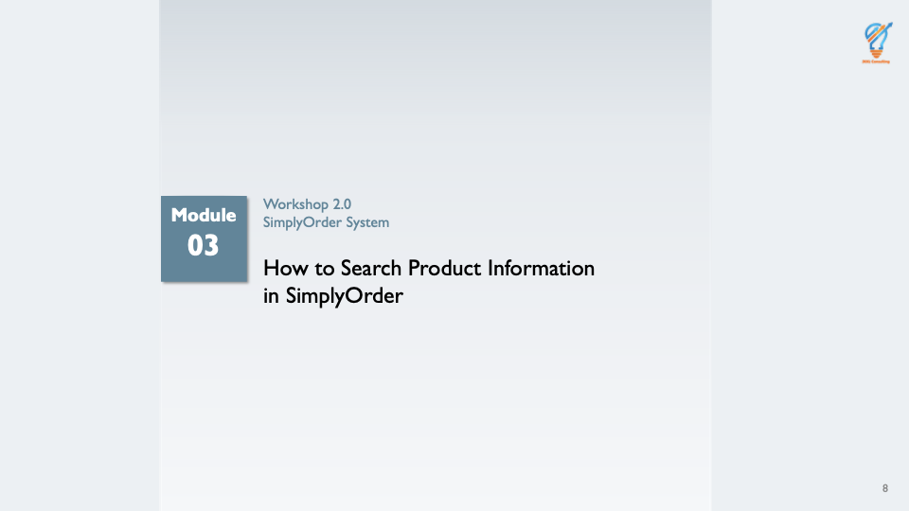
Show the PowerPoint slide titled “3.1 Course Overview.”  Review topics to be covered in this module.  Inform learners they will practice using search functionality of SimplyOrder throughout module and at end with assessments. |  | Overview  In this module, you will learn:  - How to use Search functionalities in SimplyOrder  - How to use Search functionalities individually or as a combination  You will have the opportunity to practice using the search functionality during the module as well as at the end during assessments.  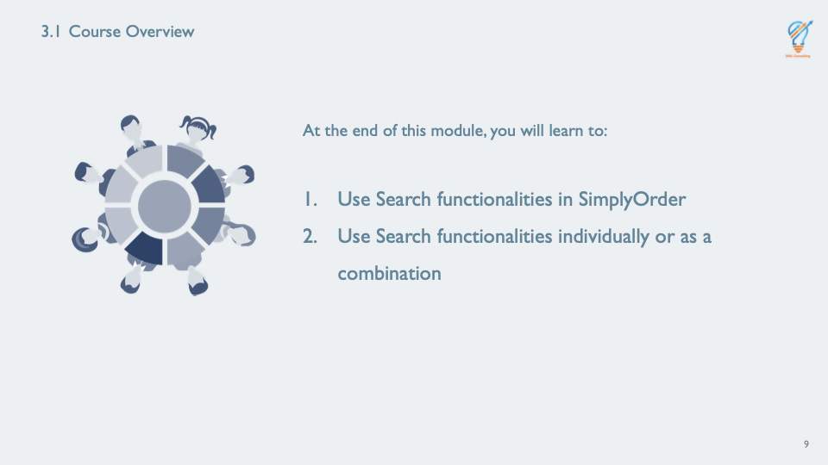
Show PowerPoint slide titled “3.2 Importance.”  Inform learners that by learning how to accurately and efficiently search for production information, customer service satisfaction will improve. |  | Importance  By learning how to search product information successfully, you will be able to:  - Answer customer questions regarding products  - Place orders accurately from clients  - Reduce call durations  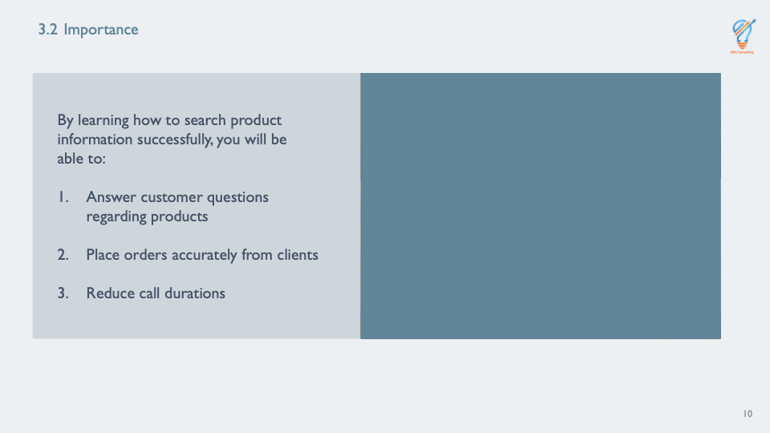
Show PowerPoint slide titled “Module Objectives.”  Inform learners of the objectives for Module 3. |  | Module Objectives  By the end of this module, you will be able to:  - Find a product within 60 seconds when provided with the product, product number, product name, or keyword  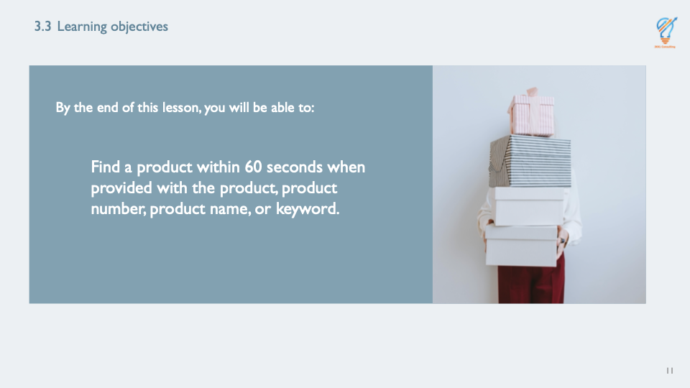

Using Search Functionality
Show PowerPoint slide titled “3.4 Using Search Functionality: Procedure.”  Inform learners HP&M acknowledges their need to easily search and access products.  Explain why searching for products accurately is an essential and crucial step toward achieving customer satisfaction.  Inform learners where Search Criteria can be access by clicking on Search button.  Highlight exactly where Search button is on interface with assistance of enlarged screen.  Inform learners each function will be shown on the sandbox and they will have time to practice if after each demonstration. |  | Using Search Functionality: Procedure  The primary goal in customer service is customer satisfaction. That goal is achieved when customer expectations of product quality and questions are met. As part of such expectations, customers expect you to answer their queries promptly as well as take their orders quickly. You have realized this can be done when you are able to access the product information efficiently. This is how the Search function of SimplyOrder simplifies this for you.  As you are aware, customers are mailed catalogs which contain the names and numbers of products. In order to access the Search Criteria listed above, find “SEARCH” button on the main navigation bar. This slide displays an example of a pop-up window that appears when you click the Search button.  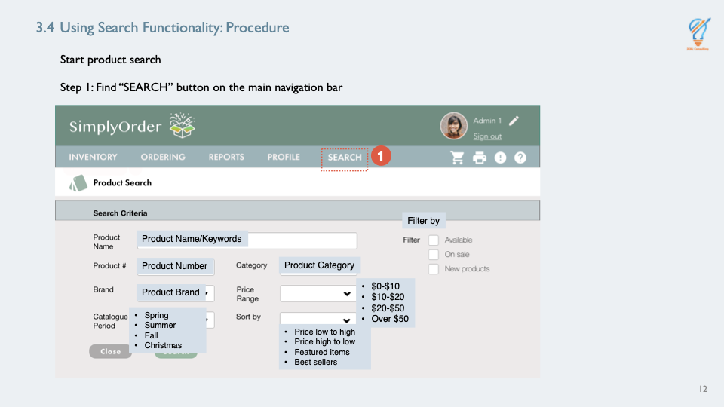
Continue showing PowerPoint slide titled “3.4 Using Search Functionality: Procedure.”  Cover the steps.  Inform learners instructor will demonstrate each function first and they will have opportunity to practice themselves  Demonstrate all seven ways to search for a specific product on the sandbox.  . |  | Using Search Functionality: Procedure  To find specific products, use the following steps:  - Find Search field on SimplyOrder navigation bar and click on it  - Enter or search using one or more of the following attributes to search for a product:  - Product Name/Keywords OR  - Product Number OR  - Brand OR  - Catalogue Period OR  - Category OR  - Price Range OR  - Filter by  - Review pop-up results window  - Select the appropriate item from the pop-up window  - Click the Close button to exit the pop-up window
Show PowerPoint slide titled “3.4.1 Using Search Functionality:  Product Name/Keywords.”  Switch from presenting slide to SimplyOrder sandbox.  Log-in to sandbox, if have not already. Have learners log in to their account.  Demonstrate how to search products by entering the following product name/keyword: Christmas Candle Bundle. |  | Product Name/Keywords  Use this function to enter Product Name or Keywords in search to bring up products.  - Search Example: Christmas Candle Bundle  This slide displays an example of a pop-up window that appears when you search product name/keyword.  I am going to demonstrate how to use this search function and give you the opportunity to practice with other functions next.  Look at search results in pop-up window.  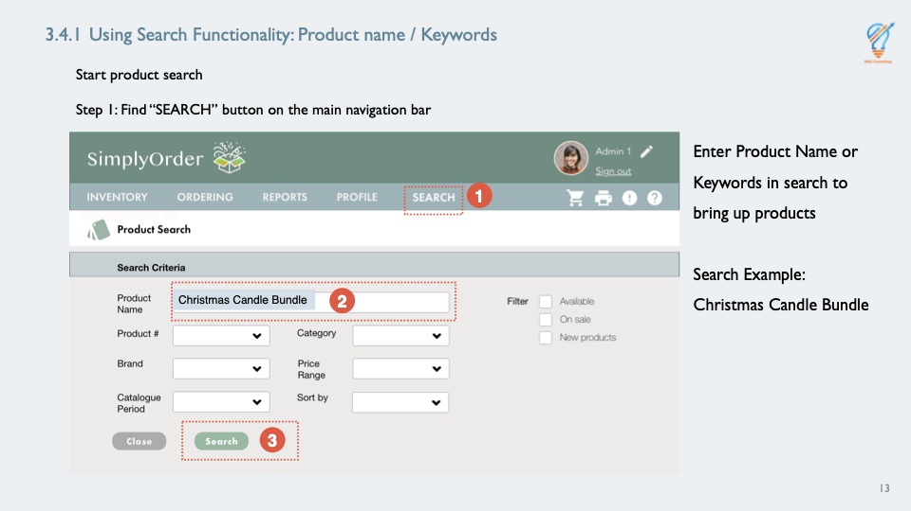
Point out search results in the pop-up window. |  | Search Result Page  When finished, I will click close button to return to search criteria.  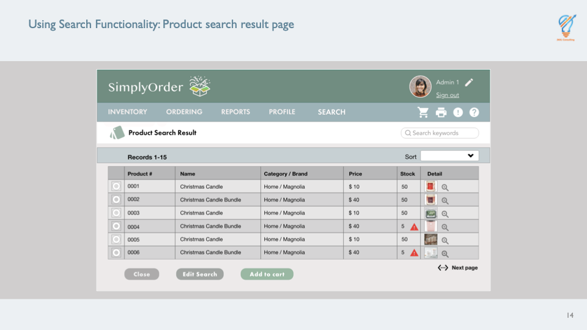
Show PowerPoint slide titled “3.4.2 Using Search Functionality: Product Number.”  Instruct learners to search products by entering the following product number: 0001. |  | Product Number  Use this function to search by Product Number to bring up products.  - Search Example: 0001  This slide displays an example of a pop-up window that appears when you search product number.  Type in “0001” in search for product number and click search. Look at search results in pop-up window.  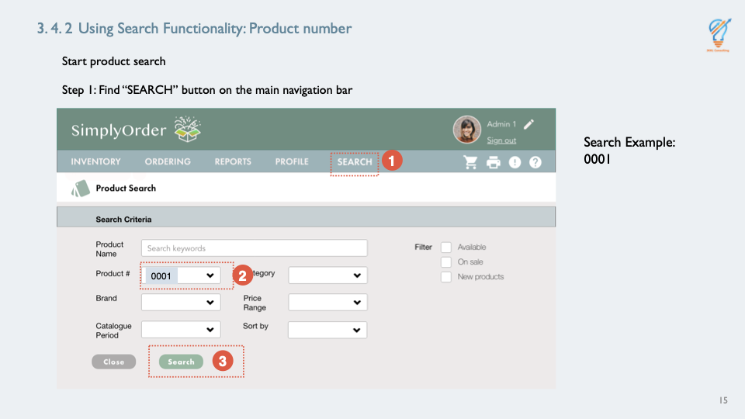
Show PowerPoint slide titled “3.4.3 Using Search Functionality: Brand.”  Instruct learners to search products by entering the following brand: Magnolia. |  | Brand  Use this function search by Brand to bring up products.  - Search Example: Magnolia  This slide displays an example of a pop-up window that appears when you search by brand.  Type in “Magnolia” in search for brand and click search. Look at search results in pop-up window.  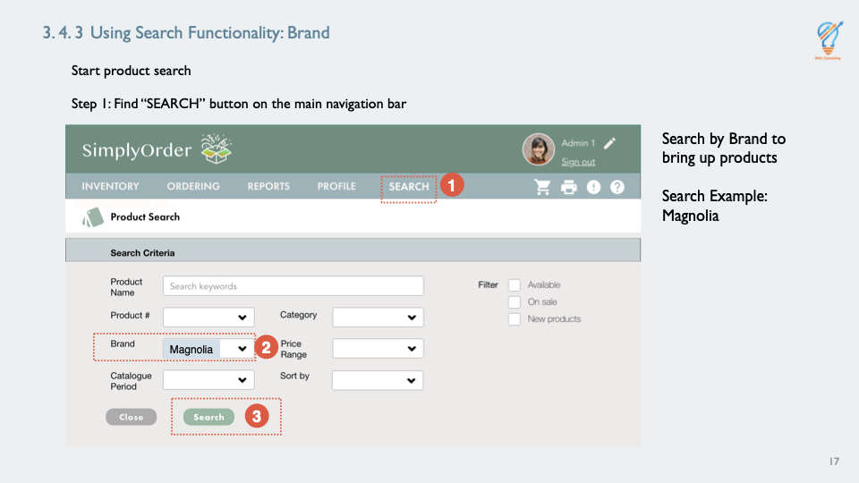
Show PowerPoint slide titled “3.4.4 Using Search Functionality: Catalogue Period.”  Instruct learners to search products by clicking the following Catalogue Period: Christmas. |  | Catalogue  You have four options to choose from when searching by Catalogue to bring up products:  - Spring  - Summer  - Fall  - Christmas  - Search Example: Christmas  This slide displays an example of a pop-up window that appears when you search by Catalogue Period.  Click on “Christmas” in search for Catalogue Period and click search. Look at search results in pop-up window.  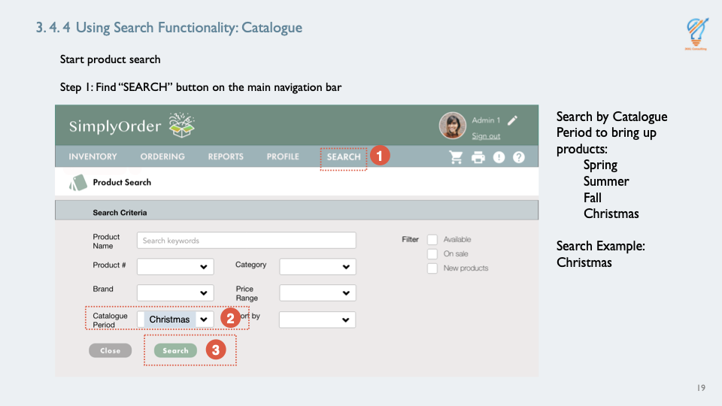
Show PowerPoint slide titled “3.4.5 Using Search Functionality: Category.”  Instruct learners to search products by clicking the following Category: Home. |  | Category  You have six options to choose from when searching by Category to bring up products:  - Home  - Furniture  - Seasonal  - Gifts  - Clothing  - Christmas Holiday  - Search Example: Home  This slide displays an example of a pop-up window that appears when you search by Category.  Click on “Home” in search for Category and click search. Look at search results in pop-up window.  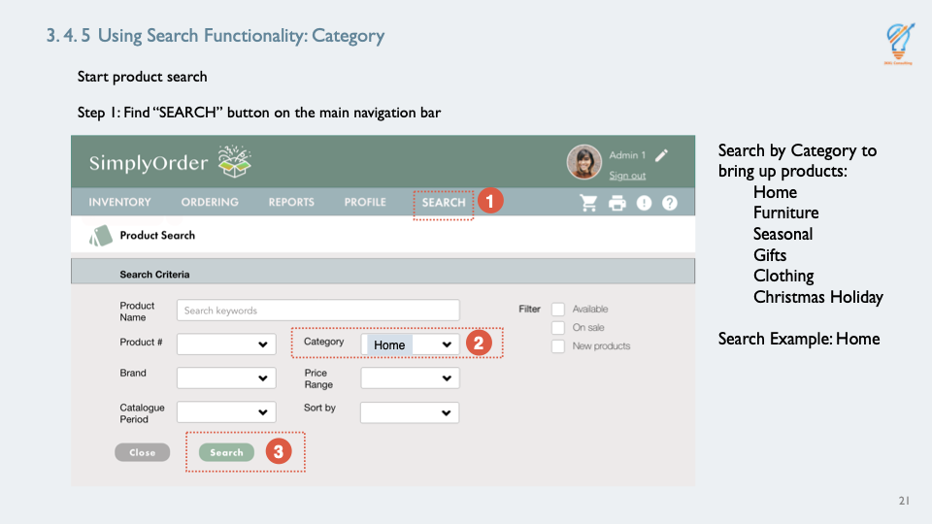
Show PowerPoint slide titled “3.4.6 Using Search Functionality: Price Range.”  Instruct learners to search products by clicking the following Price Range: $20-$50. |  | Price Range  You have four options to choose from when searching by Price Range to bring up products:  - $0-$10  - $10-$20  - $20-$50  - $50+  - Search Example: $20-$50  This slide displays an example of a pop-up window that appears when you search by Price Range.  Click on “$20-$50” in search for Price Range and click search. Look at search results in pop-up window.  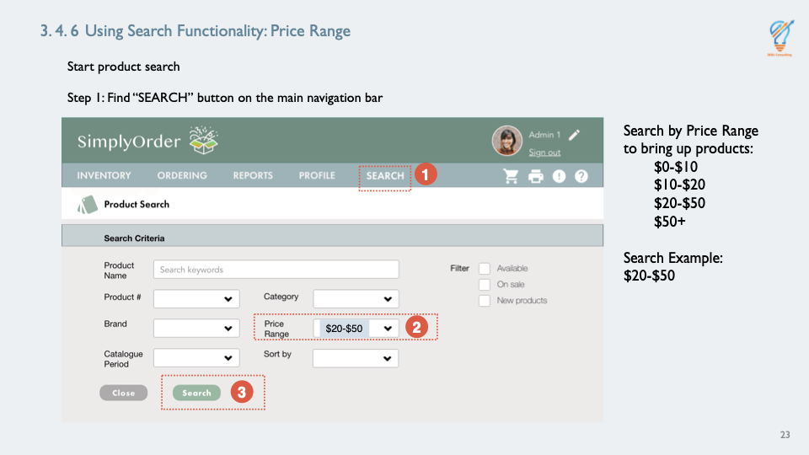
Show PowerPoint slide titled “3.4.7 Using Search Functionality: Filter By.”  Instruct learners to search products by clicking the following Filter By: Available. |  | Filter By  You have three options to choose from when searching Filter By to bring up products:  - Available  - On Sale  - New Products  - Search Example: Available  This slide displays an example of a pop-up window that appears when you search Filter By.  Click on “Available” in search for Filter By and click search. Look at search results in pop-up window.  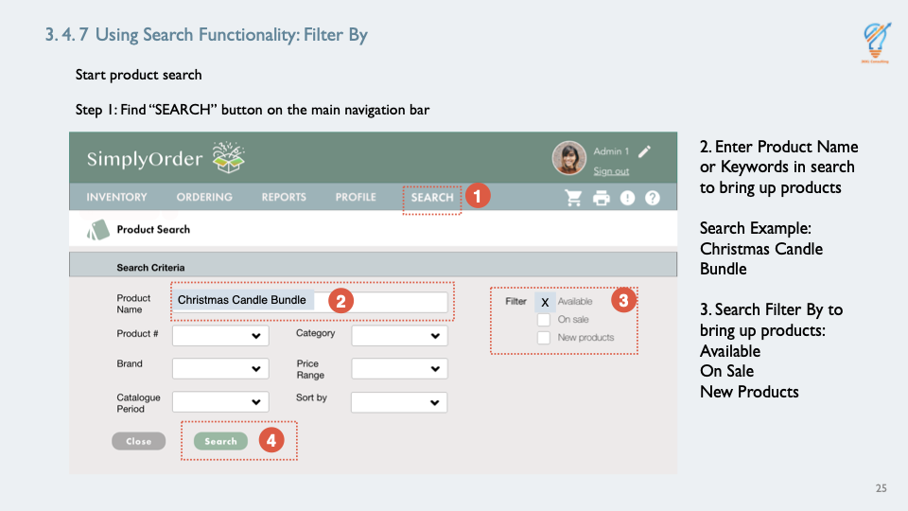
Continue showing PowerPoint slide titled “Using Search Functionality: Product search result page.”  Inform learners multiple product attributes can be searched at once in the Search functionality to further narrow down search.  Demonstrate how to search products by entering the following product attributes:  - Product Name/Keyword: Christmas Candle Bundle  - Brand: Magnolia  - Filter By: Available  - Click Search button. |  | Using Search Functionality: Search Results Pop-Up Window  It may happen when customers call, they will give you just the product name, number, brand, catalog period, category, price range, or a combination of several attributes. After confirming with the customer, select the desired product. Once you’ve successfully searched the product, you can easily access other product-related details that will be helpful to resolve customer queries.  This slide displays an example of a pop-up window that appears when you search using multiple attributes.  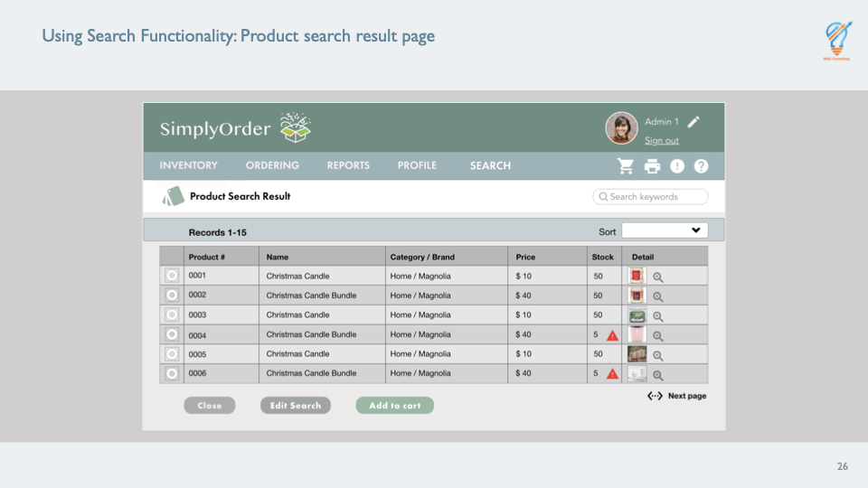
Show PowerPoint slide titled “3.5 Practice exercise.”  Explain directions for Knowledge Check scenarios. |  | Let’s Practice  Now, it’s your turn to try searching for products.  On the next three slides there will be a list of attributes a customer may ask you on the phone. Search for the product using the steps you have learned. Write down the product you would put in the cart in workbook.  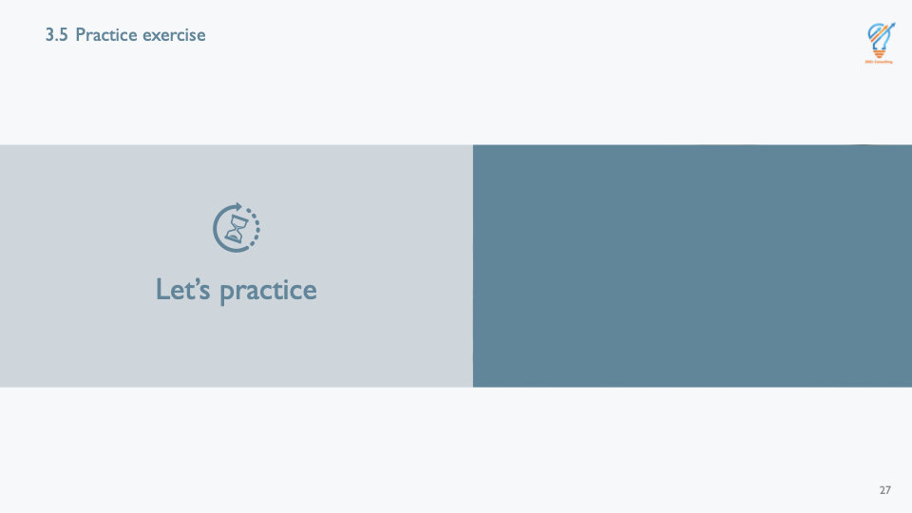
Show PowerPoint slide titled “3.5.1 Practice exercise.”  Inform learners they have three opportunities to check their knowledge searching products.  Explain answers will be discussed as a class once all three checks have been completed.  Inform learners they will have two minutes to complete each exercise.  Click next slide after learners have two minutes to search for product and write it down. |  | Your Turn: Using Search Functionality Knowledge Check #1  Here are the attributes for your second knowledge check:  - Use the search function to find the following products by entering the mentioned product attributes:  - Product Name/Keywords: 3-wick candle, white candle  - Brand: Magnolia  - Price Range: $20-$50  When finished, click close button to return to search criteria.  Give learners two minutes to enter criteria and write down product.  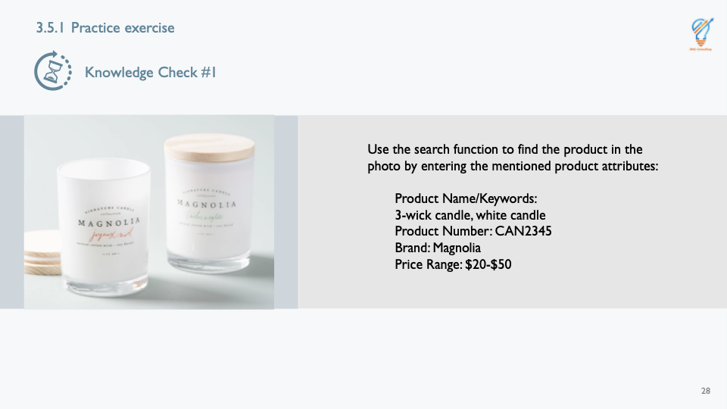
Show PowerPoint slide titled “Your Turn: Using Search Functionality Knowledge Check #2.”  Click next slide after learners have two minutes to search for product and write it down. |  | Your Turn: Using Search Functionality Knowledge Check #2  Here are the attributes for your second knowledge check:  - Use the search function to find the following products by entering the mentioned product attributes:  - Product Name/Keywords: Irish knit cardigan, sweater, Ivory  - Product Number: CAR4203  - Catalogue Period: Christmas  When finished, click close button to return to search criteria.  Give learners two minutes to enter criteria and write down product.  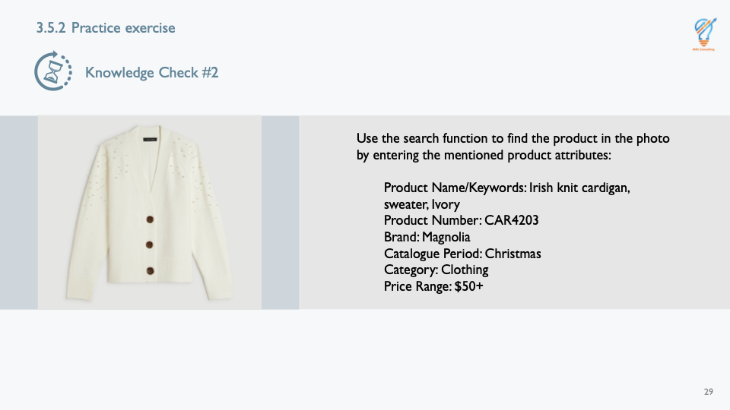
Show PowerPoint slide titled “Your Turn: Using Search Functionality Knowledge Check #3.”  Click next slide after learners have two minutes to search for product and write it down. |  | Your Turn: Using Search Functionality Knowledge Check #3  Here are the attributes for your second knowledge check:  - Use the search function to find the following products by entering the mentioned product attributes:  - Product Name/Keywords: personalized tumbler, cup, galaxy tumbler  - Product Number: TUM2345  - Price Range: $20-$50  When finished, click close button to return to search criteria.  Give learners two minutes to enter criteria and write down product.  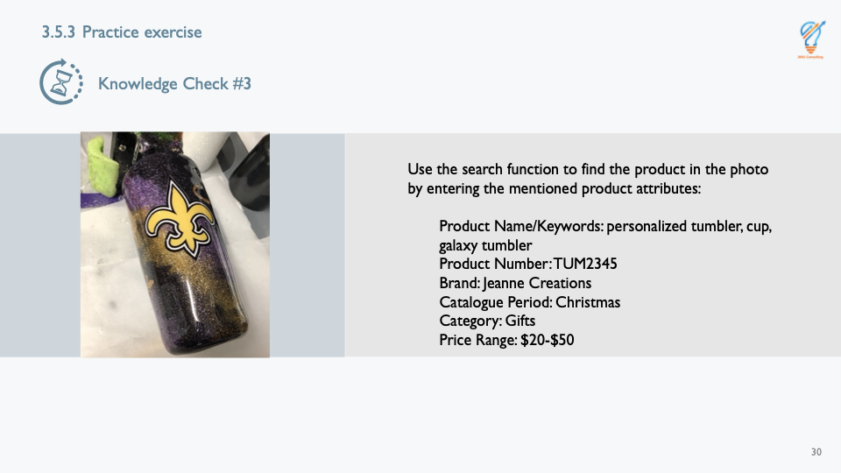
Switch screen to SimplyOrder sandbox.  Ask learners for answers of the exercise.  Answers:  - Knowledge Check #1: Magnolia 3-Wick White Candle  - Knowledge Check #2: Homemade Irish Knit Cardigan in Ivory  - Knowledge Check #3: Jeanne Creations Galaxy Tumbler  Demonstrate find each “knowledge check item” yourself. |  | Review and Summary: How to Search Product Information in SimplyOrder  Review Answers:  What products did you put in your carts as a result of the product search for each knowledge check?  - Knowledge Check #1?  Demonstrate using search criteria, find product, and add it to cart.  - Knowledge Check #2?  Demonstrate using search criteria, find product, and add it to cart.  - Knowledge Check #3?  Demonstrate using search criteria, find product, and add it to cart.
Switch screen and show PowerPoint slide titled “3.6 Review and Summary: How to Search Product Information in SimplyOrder.”  Review each step of the How to Search for Product Information in SimplyOrder. |  | Slide Review:  - As a reminder, you learned to use a combination of the following criteria in the Search Functionality to bring up products:  - Product Name/Keywords  - Product Number  - Brand  - Catalogue Period  - Category  - Price Range  - Filter By  - Review pop-up results window  - Select appropriate item from pop-up window  - Click Close button to exit pop-up window  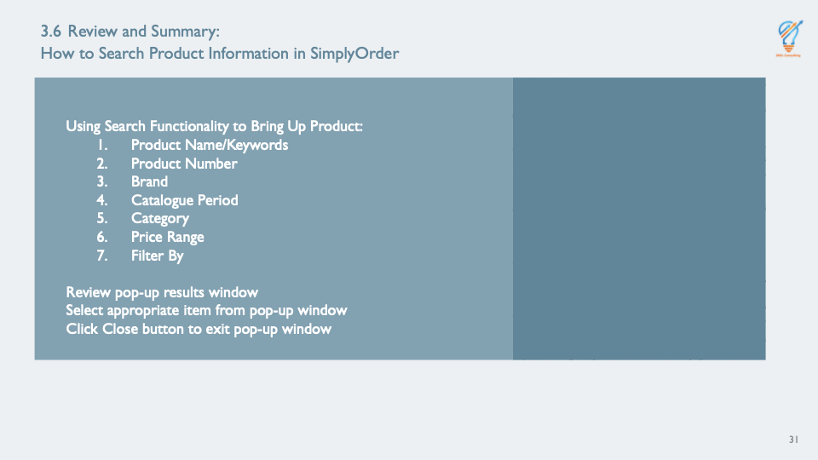
Show PowerPoint slide titled “3.7 Review and Summary.”  Facilitate discussion around finding products. Ask learners what questions they might still have after demonstrations and review. |  | Question and Answer  Discussion Questions:  - Were you able to find all the products listed in each knowledge check?  Which method of searching took the most time? Check-In:  - What questions do you still have?
Continue showing PowerPoint slide titled “3.7 Review and Summary.”  Inform learners they have a fifteen-minute break and what training topic is next. |  | Next…  You will have a fifteen-minute break to use the restrooms, stretch your legs, and grab some refreshments.  The next training will be on “How to Place a New Order.”

