Project Plan for
JKKL Consulting – Team #1
Sunday, December 6, 2020

Project Information [KP]

Project Name
The title for this project is Customer Service and SimplyOrder Skills for Telephone Operators.

Project Background and Description
Happy Products and More (HP&M) is a mail-order and Internet catalog business marketing high-quality gifts, apparel, and home accessories. In operation for six years, HP&M is seeking to aggressively grow their company while remaining profitable. To reach this goal, they would like to focus efforts on improving the quality of customer service and resulting customer service scores by 10% and improve the quality of the work environment through staff development and recognition.

Management has identified several areas of concern. Employee retention and morale are low. Customer service complaints have increased 30% since the same period in the previous year. In the coming year, HP&M will be updating its current technology including new hardware configurations and equipment. Additionally, new HR policies were recently introduced along with a new company handbook. HP&M has designated a budget of $400,000 to employ JKKL Consulting to assist the company in reaching their determined growth goals through training to address these concerns.

JKKL Consulting conducted a full gap analysis to assess current conditions at HP&M and identified key sources impacting telephone operator performance and customer service. The results of the analysis and recommendations were presented to Jane MacKenzie during a stakeholder meeting in which both parties determined the solutions most appropriate to implement.

After evaluating the analysis results, the conclusion was made that a three-prong approach would be most beneficial. The training will be divided into two areas: Customer Services Skills and SimplyOrder System. In addition to the training, JKKL Consulting will incorporate Sarah Commons and Maria Gomez into the trainings to watch and lead sessions on their own, with guidance as needed during trainings for Telephone Operators.

Project Purpose
The purpose of this project for Happy Products & More is to provide training for the Telephone Operators and Customer Service Supervisors in conjunction with the SimplyOrder development and implementation phase. The goals are to improve customer service, increase efficiency, and enrich Telephone Operator employee satisfaction.

Business Objectives
Training the Telephone Operators in areas to include telephone etiquette, customer service skills, marketing skills, specialized product knowledge, and other expertise previously escalated to Supervisors will result in improved customer service satisfaction. That, along with the accurate and consistent product data in SimplyOrder, will increase the speed and accuracy in which the Telephone Operators will be able to respond to customer service questions. In addition, providing guidance for the facilitators/trainers will lead to opportunities for employee growth and further enhance overall employee satisfaction. The updated training, product database, and trainer coaching will enhance employee satisfaction and decrease turnover. These combined updates will help Happy Products & More reach the total sales goal of seven million dollars this year.

Scope Statement [KP]

Deliverables Included
JKKL Consulting will provide training divided into two areas: Customer Service Skills and SimplyOrder System. Each training session will be four hours for a total of eight hours. There will be four main training sessions and one make-up session for each component. The trainings will be instructor-led, provide hands-on practices, and provide instructional and training materials.

- The Customer Services Skills training will include telephone etiquette, scripts, dealing with difficult customers, addressing complaints, escalating calls to supervisors as needed, and marketing/cross-marketing products.
- The SimplyOrder training will include hands-on practice with the system including:
  - locating products and details
  - placing new orders
cancelling existing orders
  - processing returns and/or exchanges
  - updating customer information
- JKKL Consulting will incorporate Sarah Commons and Maria Gomez into the trainings to watch and lead sessions on their own, with guidance as needed during trainings for Telephone Operators.

In addition to facilitating these trainings, other material deliverables included in scope are:
- Course design document
- PowerPoint slides used during training
- Handouts used during training
- Scripts/job aids used on-the-job as a resource
- Assessment question and answer scenarios
- Role-play scenarios and activities for experiential learning
- Facilitator Guide

Exclusions
Other possible solutions that were discussed, but will not be included in this training project are:
• Any materials, guides, or documentation outside that specified above
• Consultation with IT regarding product information layout and screen flow of the database
• Train-the-Trainer Program
• Management Training Program

Project Completion Criteria
The project will be complete when all specified deliverables, specific to Customer Service Training, and SimplyOrder Training, are signed off and delivered to Happy Products & More management.

Project Plans [LF]

Primary Plans
The project will consist of the following plans:
- Schedules and time commitments for JKKL Consultants and HP&M sponsor, SMEs, in-line trainers, and reviewers.
- Scheduled meetings, both face-to-face and virtually
- Status reports
- Milestones
- Change management
- Communication
- Quality control (using the Plan-Do-Check-Act model)
- Budget for time, materials, and other expenses Scheduled Meetings
Meeting | Frequency | Attendees | Description
Initial Kickoff Meeting | Once | Project Sponsor  HP&M SMEs and IT representatives  JKKL Team | Introduce JKKL team and their role in the project  Overview of the project (scope and deliverables)  Project purpose and objectives
Team meetings | Weekly  (virtual meeting) | JKKL Team  Project Sponsor | Project progress  Planning for next phase  Discuss any adjustments  Issue resolution
Progress meeting | Bi-weekly | JKKL Team  Project Sponsor  SMEs and trainers  IT staff | Project progress  Planning for next phase  Discuss any adjustments  Issue resolution
Wrap-up Meeting and Debrief | Once | JKKL Team  Project Sponsor  SMEs and trainers  IT staff | Review project outcomes  Feedback on process and project deliverables  Plan for next phase of project

Scheduled Status Reports
Weekly to Project Manager by Instructional Designers – Status reports of instructional development progress, including instructional strategies, overall design and topic sequencing, assessments and knowledge checks, and issues encountered.
Monthly to Project Sponsor – Status report of project progress including issues that have been addressed and still need resolution, schedule status, milestone completion, and budget.

Assumptions

JKKL Consulting is responsible for:
- Design, development, and delivery of agreed-upon products and services.
- Customer service training
- SimplyOrder training
- Project management with bi-weekly status reports to Jane MacKenzie.
- Adherence to project milestones (dates and deliverables).
- Timely communication of events that might impact the timeline and delivery of agreed-upon products and services.

Happy Products & More is responsible for:
• Providing training room facilities and equipment.
• IT support for the SimplyOrder system and workstation performance.
• Printing materials, including training handouts facilitator guides, and job aids.
• Providing SMEs and ensuring access to said SMEs by JKKL Consulting.
• Access to the SimplyOrder test system/sandbox.
• Data entry of product information into the SimplyOrder system.
• Scheduling Telephone Operators for training sessions.
• Timely communication of events that might impact the timeline and delivery of agreed-upon products and services.

Constraints
These situations will constrain JKKL Consulting’s ability to successfully carry out the project:
• Access to and scheduling time with SMEs who work various shifts, weekends, and holidays, and who have other job responsibilities.
• The IT schedule for development, implementation and “go live” of the SimplyOrder system.
• Holiday closures and time-off which reduce available project worktime for both JKKL and HP&M.

External Dependencies
Successful completion of the project is dependent on the following external factors:
• SimplyOrder vendor technical support and compliance with contractual obligations.
• Vendor delivery of product information for the Fall catalog and data entry into SimplyOrder.

Project Approach
For this project, JKKL Consulting will use the ADDIE Process:
• Analyze:
  - Needs Assessment
  - Performance Gap Analysis
  - Job Task Analysis
• Design:
  - Design Document
  - Create training outline and determine assessments
• Develop:
  - Training Materials (Student and Facilitator guides)
  - Training Activities and Assessments
  - Job Aids
  - Customer Service Scripts
  - Power Point/Training Slides
• Implement:
  - Customer Service Skills Training
  - SimplyOrder Training for Telephone Operators
• Evaluate:
  - Assess learners during training
  - Evaluation survey regarding training and materials
  - Evaluate TOs on the job, including retention and satisfaction
  - Analyze and report data

Milestones
Milestone | Date
Customer Service and SimplyOrder Design Document signoff | 4/23/2021
Customer Service Facilitator Guide and Instructional Slides signoff | 5/6/2021
Customer Service Pilot training conducted | 5/21/2021
Customer Service Course Revision sign-off | 5/28/2021
SimplyOrder Facilitator Guide and Instructional Slides signoff | 6/20/2021
SimplyOrder Pilot training conducted | 6/25/2021
SimplyOrder Course revision signoff | 6/30/2021

WBS Diagram
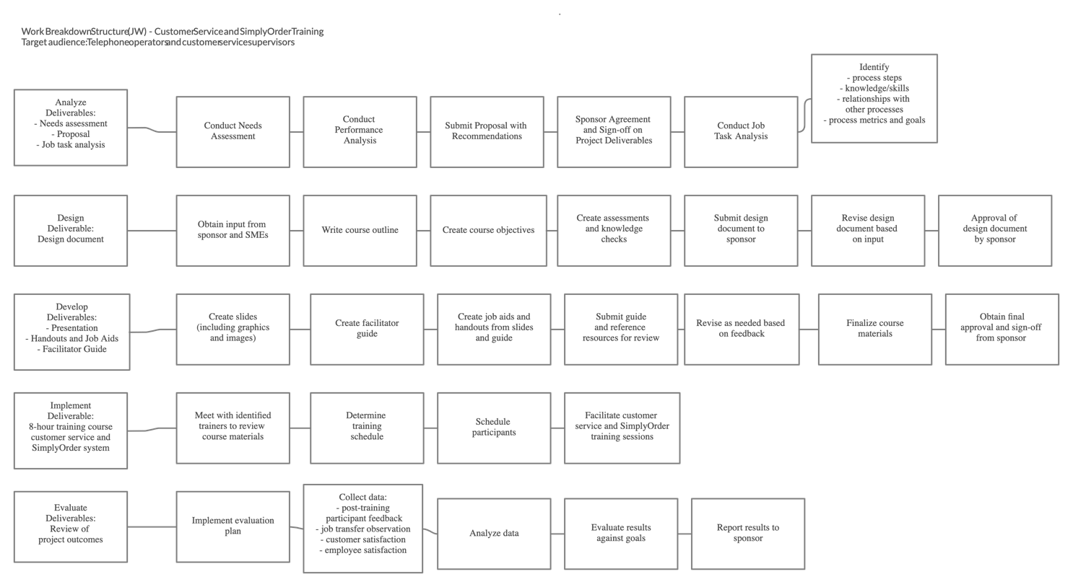

Schedule
Stage | Role | Task | Start date | End date | Duration (in days)
Analyze | Project manager, instructional designer | Create Needs assessment, Proposal, and Job task analysis | March 18 | April 12 | 26
 |  | Conduct needs assessment and performance analysis | March 18 | March 25 | 6
 |  | Conduct content analysis | March 22 | April 2 | 8
 |  | Conduct sponsor meeting | March 25 | March 29 | 5
 |  | Write and submit charter | April 3 | April 3 | 1
 |  | Interview SMEs | April 4 | April 9 | 4
 |  | Conduct job task analysis | April 4 | April 10 | 5
 |  | Conduct learner and training analysis | April 8 | April 12 | 5
Design | Instructional designer, SME | Create design documents | April 15 | April 23 | 9
 |  | Choose course content development tools | April 15 | April 15 | 1
 |  | Finalize the visual design guidelines (color, font, and formatting) for training material | April 15 | April 15 | 1
 |  | Create Course Outline | April 15 | April 15 | 1
 |  | Draft design document, including learning strategies, activities, and assessment methods | April 16 | April 20 | 5
 |  | Submit draft of Customer Service and SimplyOrder training for review and signoff | April 20 | April 23 | 4
Development | Instructional designer, graphic artist | Create facilitator guide & Presentation | April 24 | June 20 | 58
 |  | Write first draft of Customer Service guides and exercises | April 24 | May 4 | 10
 |  | Review and submit feedback on Customer Service first draft | May 4 | May 6 | 3
 |  | Implement revisions for Customer Service | May 6 | May 9 | 2
 |  | Review final drafts and sign off for Customer Service | May 9 | May 11 | 3
 |  | Write first draft of Simply Order guides and exercises | June 1 | June 10 | 11
 |  | Review and submit feedback on SimplyOrder Customer first draft | June 10 | June 12 | 3
 |  | Implement revisions for SimplyOrder | June 13 | June 15 | 3
 |  | Review final drafts and sign off for SimplyOrder | June 16 | June 20 | 5
Implement | Instructional designer | Teach training courses (Customer Service & SimplyOrder System) | May 12 | July 10 | 60
 |  | Implement Customer Service Training course | May 21 | June 15 | 16
 |  | Notify employees of training and sessions to attend | May 12 | May 15 | 4
 |  | Conduct Customer Service pilot training session | May 21 | May 21 | 1
 |  | Revise Customer Service training, if needed | May 21 | May 25 | 5
 |  | Signoff on training revisions, if needed | May 25 | May 28 | 3
 |  | Conduct second set of trainings plus make-up session | June 10 | June 20 | 20
 |  | Implement SimplyOrder System Training course | June 25 | July 10 | 16
 |  | Notify employees of training and sessions to attend | July 1 | July 8 | 9
 |  | Conduct pilot training sessions | June 25 | June 25 | 1
 |  | Revise training, if needed | June 26 | June 28 | 3
 |  | Signoff on training revisions, if needed | June 28 | July 2 | 5
 |  | Conduct second set of trainings, including make-up sessions | July 3 | July 10 | 8
 |  | Write assessment reports | July 11 | July 17 | 7
 |  | Training complete and signoff | July 18 | July 25 | 8
Evaluate | Quality assurance specialist, Instructional designer | Post-training evaluation & analysis | July 25 | July 30 | 6
 |  | Write Evaluation Report | July 25 | July 27 | 3
 |  | Submit Evaluation Report & final training deliverables | July 28 | July 30 | 3

Gantt Chart
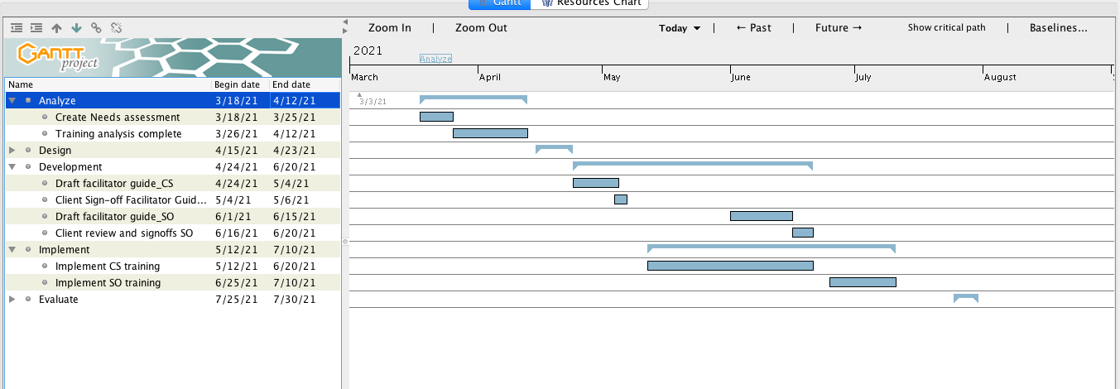

Change Management Plan [JW]

Purpose
The purpose of this plan is to provide a process by which any changes to the project scope can be identified, documented, agreed upon, including scheduling and budget changes. This plan will provide all stakeholders a means to maintain clarity on any unforeseen changes or stakeholder request that might affect the project deliverables. This plan is intended to supplement the agreed-upon plans documented in the project charter to ensure all parties involved remain in agreement on the final project outcomes.

Goals
The goals of the change management plan are to provide a coordinated process flow for tracking the submission, coordination, review, evaluation, and approval of all changes to the project’s budget, schedule and deliverable. The plan includes development of a centralized tracking database that:
  - Documents all changes related to schedule, workflow, and budget
  - Tracks scope changes and effects on budget and schedule
  - Allows for open communication among stakeholders regarding project changes
  - Provides both JKKL and HP&M a record of changes to the project plan

Change Control Process

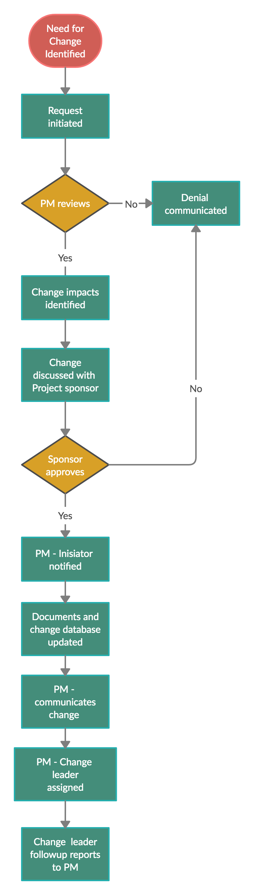

Responsibilities
Person Responsible | Responsibilities
Jeanne Wilson  Project Manager | Communicate change management process, including documentation, communication, and chain of command.  Oversee and manage use of scope change process.  Document the change, including all supporting documentation.  Coordinate the change implementation assignment and follow-up process.  Act as liaison with project sponsor regarding change.
Katie Pierre and Lei Feng | Prepare impact statements of change on project deliverables, schedule and budget.  Work with HP&M assigned staff to implement changes.
Jane MacKenzie | Review and approve/deny/request modifications.  Assign HP&M staff to work on changes that need client expertise or resources.

Project Plan Approvals [JW]

Approvals
Approved by:
Name | Role | Signature | Date
Jeanne Wilson | Project Manager
Jane MacKenzie | Project Sponsor

